

**miBuilds Web App**

**User Guide**

*for Market Development*

*West Division*

*Update Q4 2018*

# Contents

1 Contents 2

2 Welcome 4

3 Registration and Login 6

3.1 Landing Page 6

3.2 Home 6

3.3 Register 6

3.4 Login 8

3.5 Reset Password 9

3.6 Landing Page 9

3.7 Create A Business Case 10

3.8 View Business Cases 10

3.9 View Reporting 11

3.10 Test Your Upload 11

4 User Levels and Control Mechanisms 12

4.1 User Levels 12

4.2 Control Mechanisms 13

5 Create a Business Case 16

5.1 Overview 16

5.2 Create Case 19

5.2.1 Spectrum Easy Button 19

5.3 Add, Upload, Edit, Delete Building(s) 20

5.3.1 Add Building 20

5.3.2 Upload Building(s) 21

5.3.3 Edit Building 24

5.3.4 Delete Building(s) 24

5.4 Add Business(es) 28

5.4.1 Add Business 28

5.4.2 ROE ID Entry 29

5.4.3 Upload Business(es) 30

5.4.4 Edit Business 32

5.4.5 Delete Business(es) 32

5.5 Add Deal In Hand(s) 35

5.6 Add MDU(s) 35

5.6.1 Add MDU 35

5.6.2 Edit MDU 37

5.6.3 Delete MDU 38

5.7 Add Data Center(s) 39

5.7.1 Add Data Center 39

5.7.2 Edit Data Center 41

5.7.3 Delete Data Center(s) 42

5.8 Multiphase Business Cases 43

5.8.1 Description 43

5.8.2 Benefits 44

5.8.3 Process 44

5.9 Exception Processes 44

5.9.1 Caring for MDUs 44

5.9.2 Caring for address ranges. 45

6 Submit a Business Case 45

6.1 Submitting 45

6.2 Review Business Case 45

7 Approve a Business Case 46

7.1 Leads 46

7.1.1 Regional Approval 46

7.1.2 Division Approval 47

7.2 How to Edit post approval 48

8 Notes, Emails and Additional Features 48

8.1 Add Note(s) 48

8.2 Table Sorting 48

9 Reporting 49

9.1 Add Data Center(s) 49

10 User Guide Governance 49

10.1 Change Control 49

11 Appendix 49

11.1 Business Development Playbook 49

11.2 Market Development and Financial Definitions 50

Copyright © 2014 by Comcast business

# Welcome

Welcome to the miBuilds Web App User Guide! The West Division Market Development Team, and its corresponding Regional Teams, are committed to establishing a deeper reach into plant expansion for network growth. Market Development believes this objective is reached through excellence in both proactive and reactive build activity. This user guide focuses on creating a business case to achieve those goals and has been created to provide the Market Development community with the direction, guidance, and support to ensure consistency and success across regions.

The Market Development team partners with many teams to orchestrate a comprehensive market growth strategy and capitalize on the efficiencies of coordinated investment and cross-functional alignment.

This user guide is a reference tool to walk you through creating a Business Case:

* Registration and login
* User levels and hierarchy
* Navigating the web application
* Creating a business case
  + Adding additional items to the business case
  + Saving, submitting and approving a business case
  + How to edit a business case after approval
  + Multiphase business case
  + Adding Residential opportunities
* Utilizing business case notes
* miBuilds reporting features

# Registration and Login

## Landing Page

* Link: <http://codccmiplatform:8080/miBuilds/>
* The landing page will have a hamburger menu that can be utilized to get to other destinations within the site.

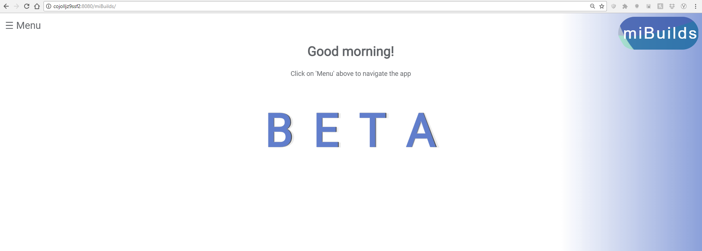

* The hamburger menu will have two different sets of options based on whether or not the user is currently logged in. Below is a view of the options when a user is not logged in. Feel free to save your username and password for the site.

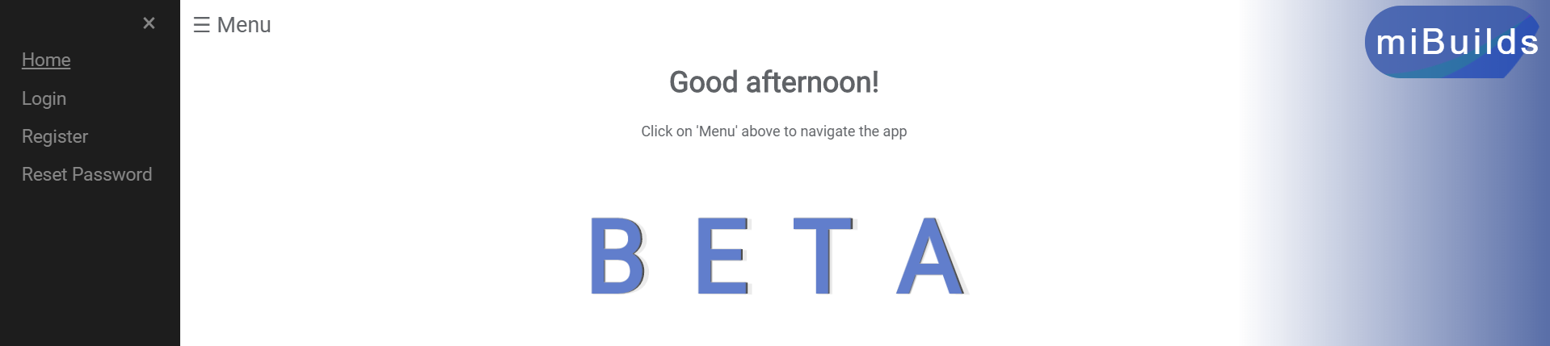

## Home

* Clicking “Home” in the hamburger menu will always take you back to the landing page.

## Register

* Step 1: Clicking, “Register” from the hamburger menu will lead you to a page where you will be asked to enter your NT Login and Comcast email to register with the web application. Once the information is accurately filled in, please hit the “REGISTER” button at the bottom.

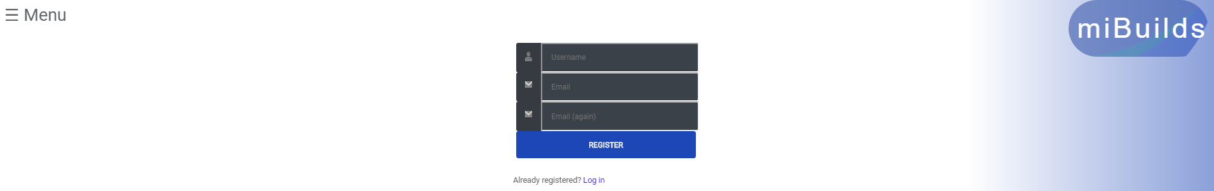

* Step 2: A registration confirmation email will be sent to you. This is to let you know that the site admin needs to verify the registration request. Please contact the site administrator if you believe they have missed your request.

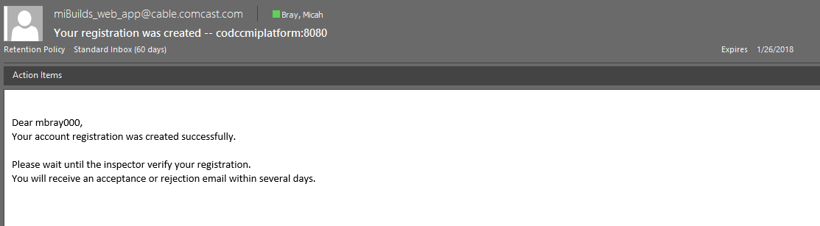

* Step 3: A registration acceptance email will be sent to you. This is to let you know that your registration was accepted by the site admin. Additionally, there will be a hyperlink in this email that will take you to a page to enter in the password you would like

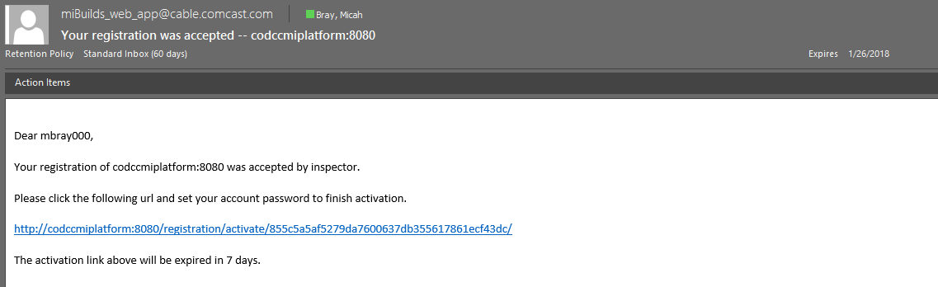

* Step 4: Enter in your desired password two times on the screen and hit “Activate” at the bottom. A subsequent screen will load that illustrates the activation was complete.

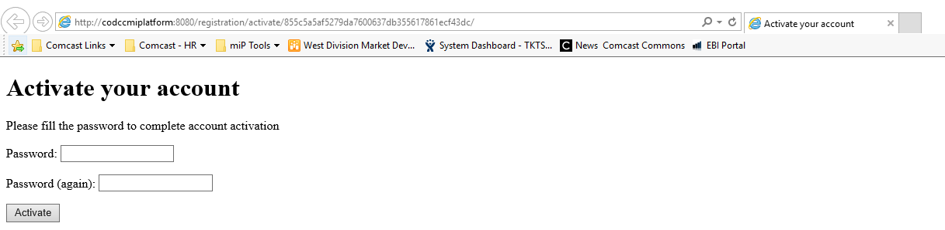

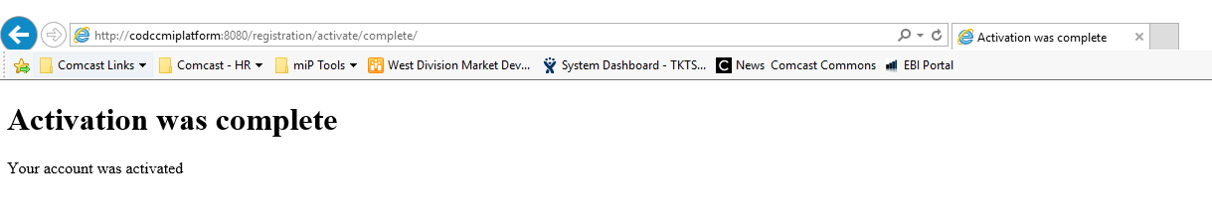

* Step 5: An account activation email will be sent to you. This is to let you know that the account was activated successfully and provides a hyperlink to the site for you to utilize your new credentials and login.

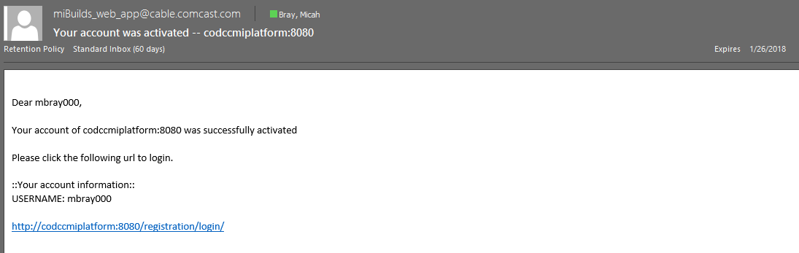

## Login

* You can get to the Login page via the link from the activation email, or by clicking, “Login” in the hamburger menu. Simply enter your NT Login (username) and password.

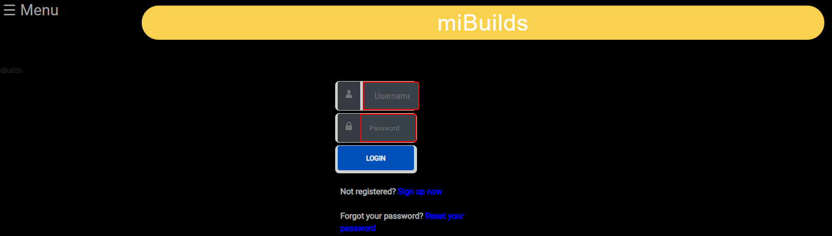

## Reset Password

* Step 1: Click “Change Password” in the hamburger menu to navigate to a page that will prompt you to enter your old password once and your desired new password twice. Hit, “CHANGE PASSWORD” at the bottom of the page to complete the process.

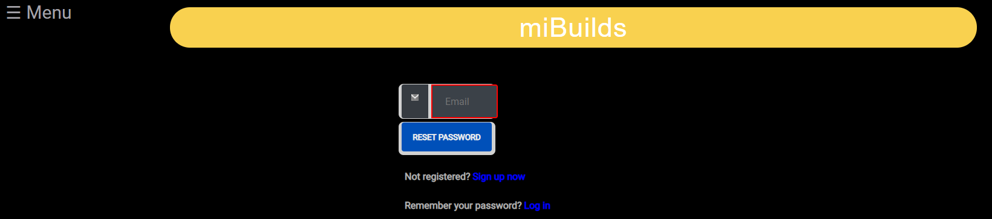

* Step 2: You will be taken to a page that confirms your password change. It is recommended to write down the new password or save within the browser.

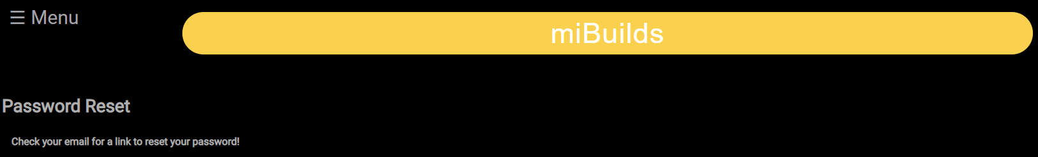

# Navigation

## Landing Page

* Link: <http://codccmiplatform:8080/miBuilds/>
* The landing page will have a hamburger menu that can be utilized to get to other destinations within the site.

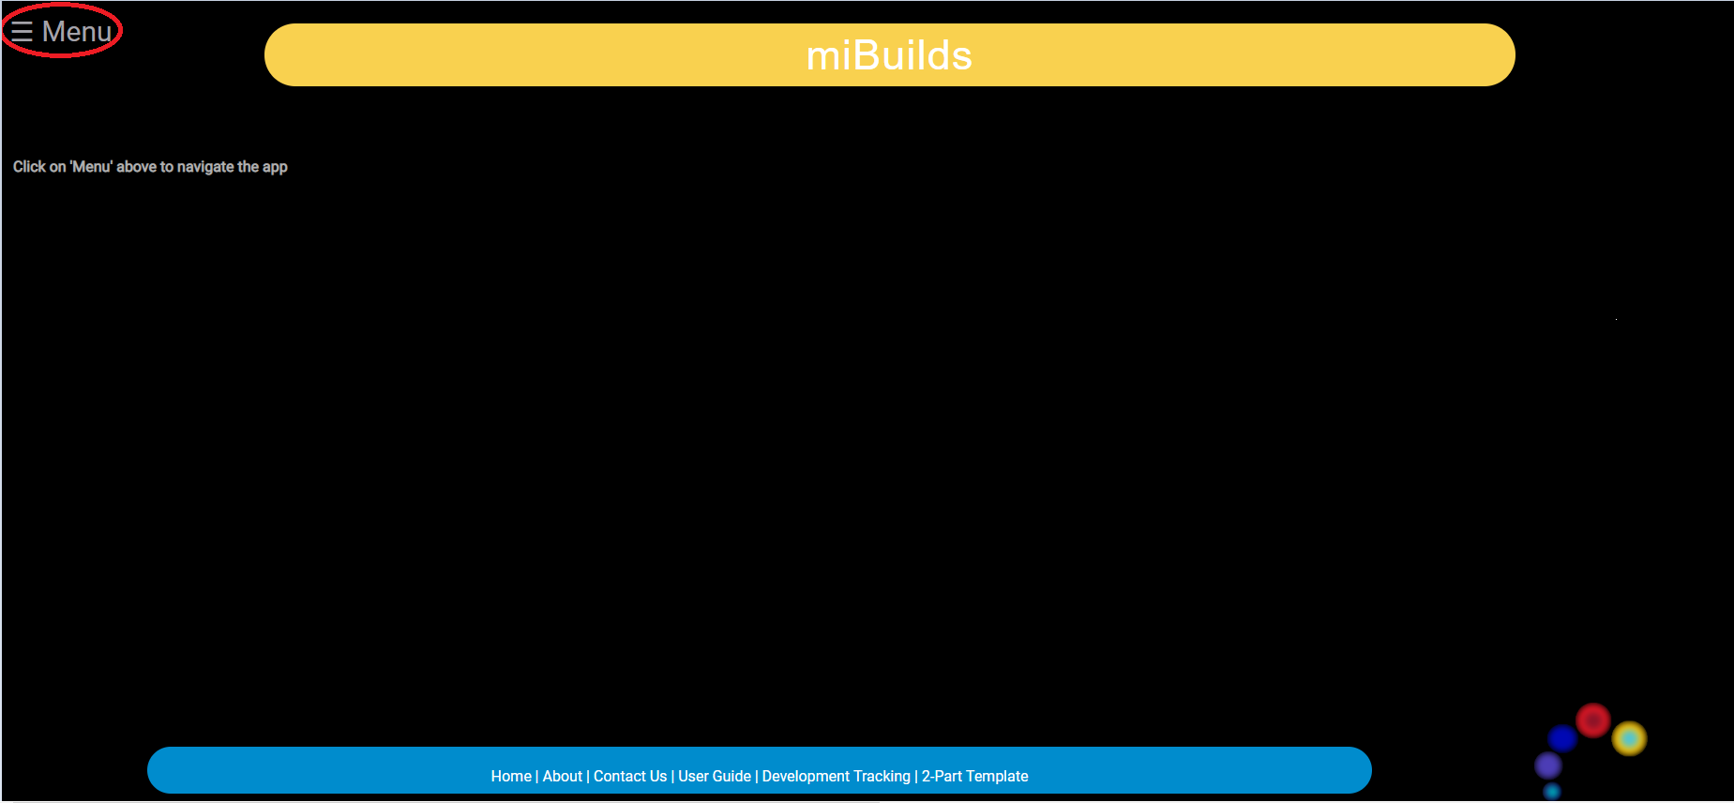

* The hamburger menu has two different sets of options based on whether or not the user is currently logged in. Below is a view of the options when a user is not logged in. Feel free to save your username and password to the site.

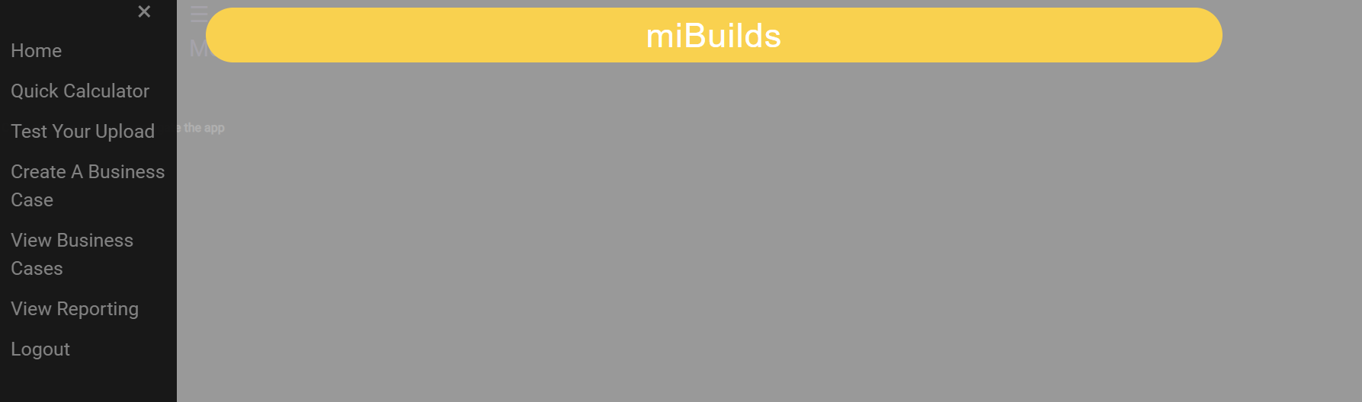

## Create A Business Case

* Clicking, “Create A Business Case” on the hamburger menu will take you to a page to start the process of creating a Business Case.
* The process of creating a Business Case will be addressed later.

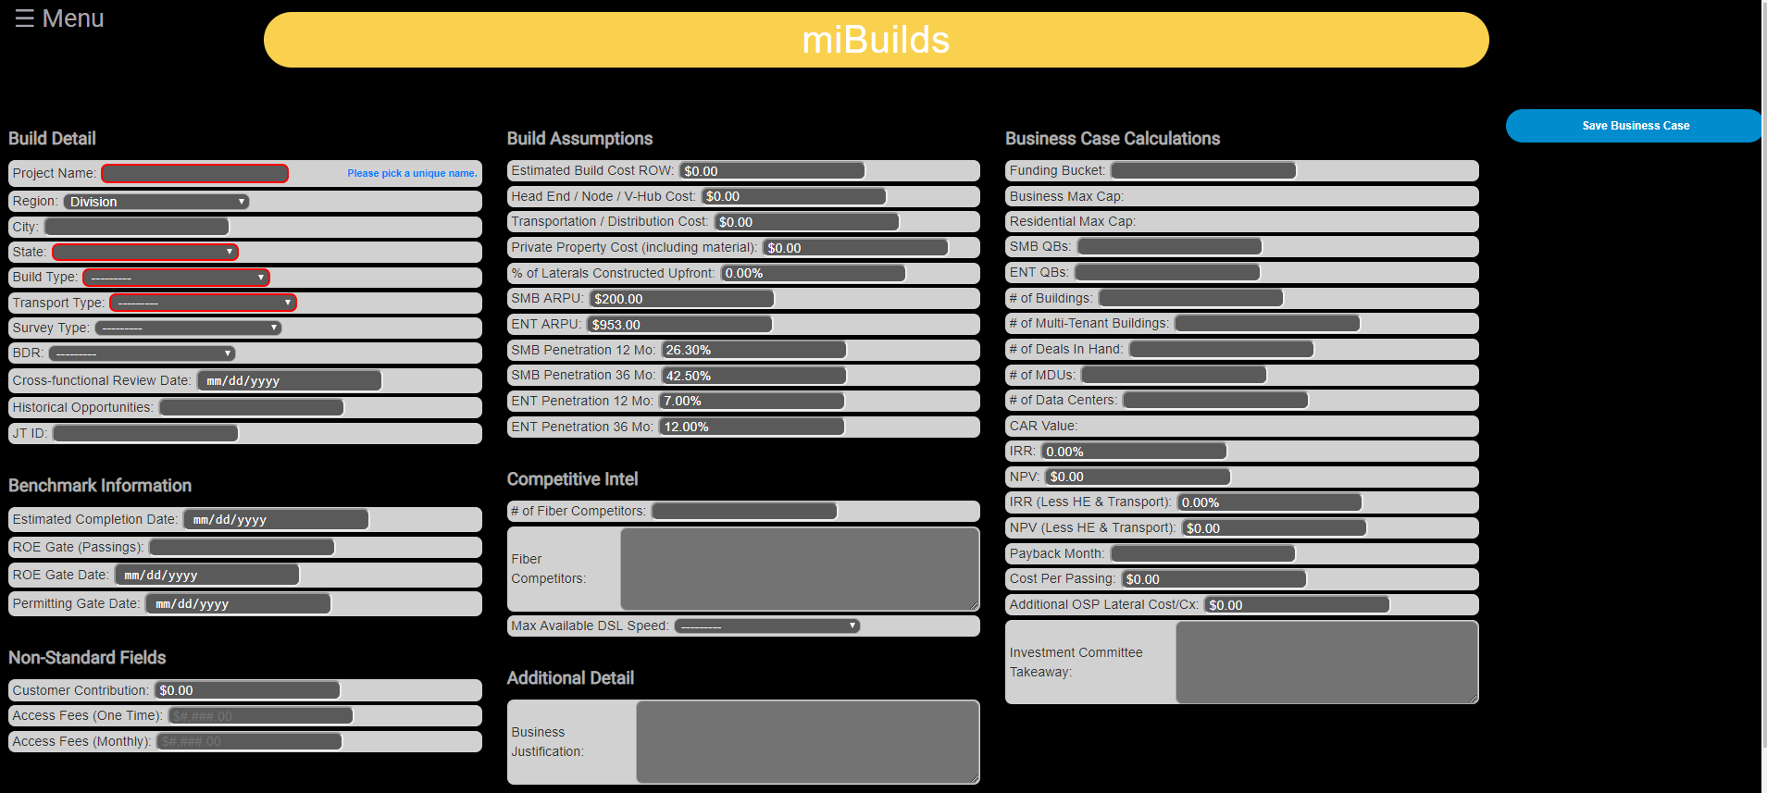

## View Business Cases

* Clicking, “View Business Cases” on the hamburger menu will take you to a page to view Business Cases in the pipeline. Here you will be able to access Pending, Submitted and Approved Business Cases.
* Buttons
  + View – clicking “View” will take you to that particular Business Case
  + Delete – clicking “Delete” will delete the Business Case from miBuilds. There are 2 prompts to make sure this is what you want to do due to the risk of deleting work.
  + Search – enter build name or created by to find an existing specific business case.

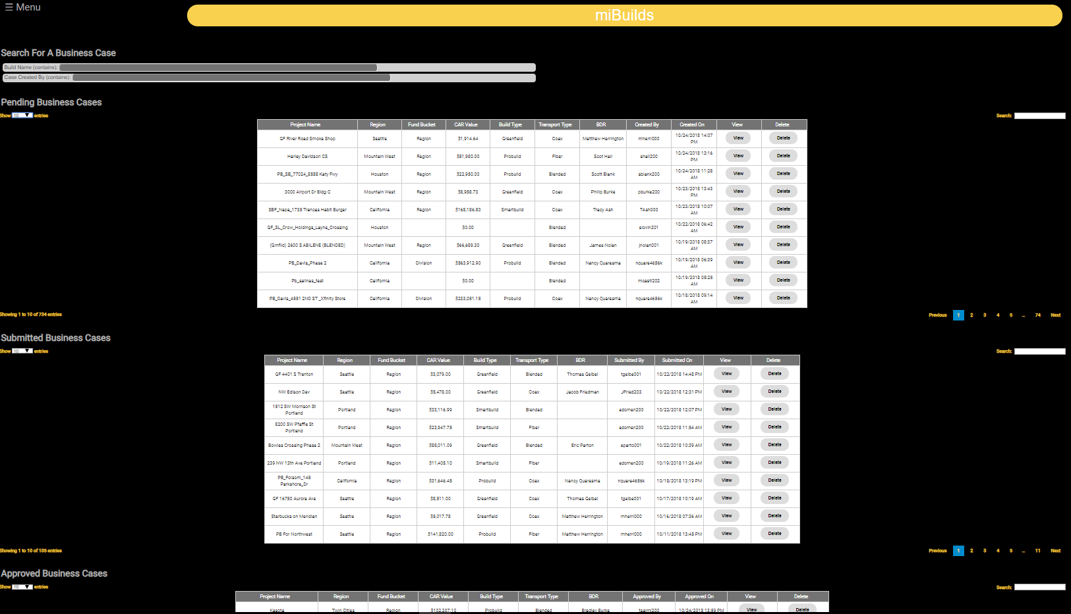

## View Reporting

* Clicking, “View Reporting” will take you the landing page for future reporting enhancements. Currently, this page has 1 summary report and has a link to the miBuilds Tableau Dashboard.

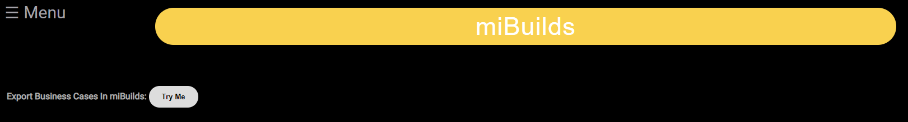

## Test Your Upload

* Clicking, “Test Your Upload” will take you to a page where you will be able to test your Spectrum Export or CSV template. You will be able to see if the headings in the file are correct and whether or not buildings or businesses in your CSV file are tied to a different build.

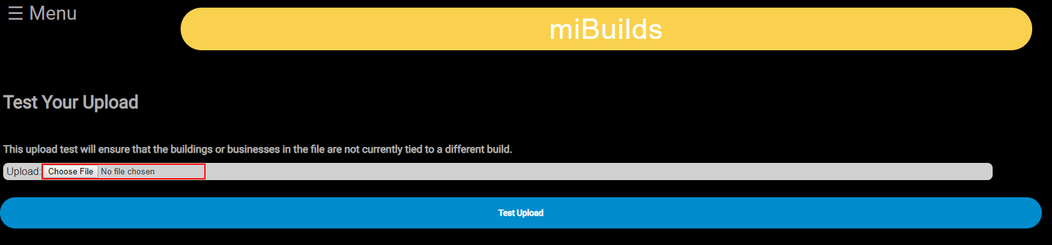

# User Levels and Control Mechanisms

## User Levels

* Level 1
  + Lowest Level
  + Future pace, for viewing only privileges within of region only
* Level 2
  + Lowest Level
  + Create – capable of creating business cases
  + Viewing – capable of viewing only business cases they have created
  + Editing – capable of editing only their business cases up to approval but not able to edit after approval
  + Submission – capable of submitting a business case for review
  + Approval – not capable of approving a business case
  + Deleting – capable of deleting only their business cases up to approval
* Level 3
  + Create – capable of creating business cases
  + Viewing – capable of viewing only business cases within the region
  + Editing – capable of editing any business case (within the region) up to approval but not after a business case has been approved
  + Submission – capable of submitting a business case for review
  + Approval – capable of approving a business case up to a certain amount
  + Deleting – capable of deleting business caes within the region only up to approval
* Level 4
  + Create – capable of creating business cases
  + Viewing – capable of viewing only business cases within the region
  + Editing – capable of editing any business case (within the region) even after it has been approved
  + Submission – capable of submitting a business case for review
  + Approval – capable of approving a business case up to a certain CAR Value
  + Deleting – capable of deleting business cases within the region
  + Pending – capable of placing an approved business case back into pending status. ***If you want to change something on the summary screen, then you need to remove it from approved. Each one of the buildings, business, etc. tabs does not affect this summary screen while the business case is in an “Approved” status.***
* Level 5
  + Create – capable of creating business cases
  + Viewing – capable of viewing all business cases within the Division
  + Editing – capable of editing any business case even after it has been approved
  + Submission – capable of submitting a business case for review and able to send a business case for approval
  + Approval – not able to approve a business case
  + Deleting – capable of deleting business cases within the Division
* Level 6
  + Create – capable of creating business cases
  + Viewing – capable of viewing all business cases within the Division
  + Editing – capable of editing any business case even after it has been approved
  + Submission – capable of submitting a business case for review and able to send a business case for approval
  + Approval – capable of approving a business of any CAR Value
  + Capable – capable of deleting business cases within the Division

## Control Mechanisms

* Required Fields
  + Denoted on the form with a red box, which will disappear when the requirement is satisfied
  + Must be filled in to complete tasks: “Save”, “Submit”, “Approve”, “Add” or “Edit”
* Autofill Fields – entering a valid ID in any of these fields will fill in the applicable fields in the rest of the form
  + Region
  + Building_Id
  + Business_Id
  + Opportunity_Id (Sales Force)
* Help Text – text or numbers next to a field that provide some help as to what is expected or the standard assumption:
  + Blue – denotes helpful text about what type of ID to use, what fields are required to move the business case along, or other key points

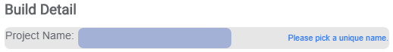

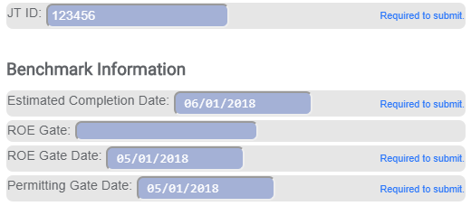

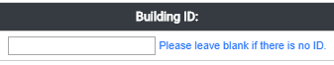

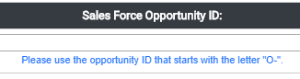

* + Green – denotes a positive numerical difference from the field’s value and the expected value based on current assumptions.

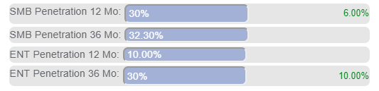

* + Red – denotes a negative numerical difference from the field’s value and the expected value based on current assumptions

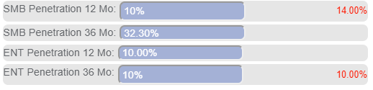

* Data Validators – checks on data that will provide an error message or prompt if the data doesn’t meet requirements or is not what is expected.

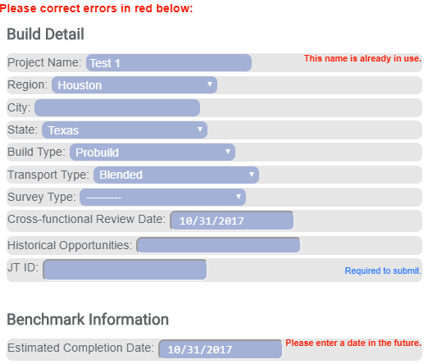

* Highlighting – buildings without a cooresponding business in the build, or businesses without a cooresponding building in the build will display as highlighted in yellow. This is to point out that there should be a cooresponding building or business.

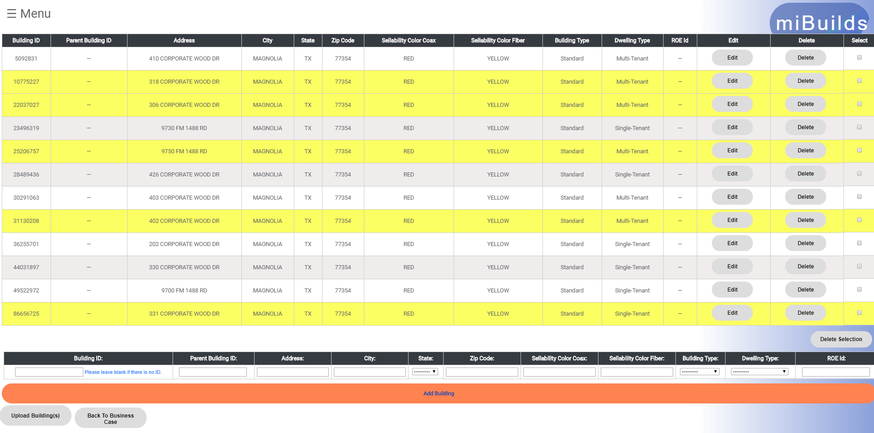

* Deletion Capabilities
  + Placeholder
* Deletion Confirmation
  + Placeholder

# Create a Business Case

## Overview

### Business Case Summary Page – Fields

* Build Detail – self explanatory fields. Enter data as appropriate.
* Benchmark Information
  + # of ROE (Passings) Targeted: this is calculated at 30%
  + # of ROE (Passings) Acquired: the # in the repository
  + # of ROE (Passings) Needed: calculated on the two fields above
  + ROE Gate Date: a date is agreed upon in the PMO meetings
  + Estimated Completion Date: a date is agreed upon in the PMO meetings
* Non-Standard Fields – self explanatory fields. Enter data as appropriate.
* Build Assumptions
  + Estimated build Cost ROW:
  + Head End / Node / V-Hub Cost:
  + Private Property Cost (including material):
  + % of Laterals Constructed Upfront:
  + SMB ARPU:
  + ENT ARPU:
  + SMB Penetration 12 Mo:
  + SMB Penetration 36 Mo:
  + ENT Penetration 12 Mo:
  + ENT Penetration 36 Mo:
* Competitive Intel – self explanatory fields. Enter data as appropriate.
* Additional Detail for Business Justification – self explanatory.
* Business case Calculations
  + Funding Bucket: Region is <$200K, Division is >$200K
  + % Business: this is the mix of commercial passings
  + % Residential: this is the mix of residential passings
  + SMB QBs: this is the count of small business coax qualified businesess
  + # of Buildings: self explanitory
  + # of Delas in Hand: this is the signed contracts for SmartBuilds
  + # of MDUs: multi dwelling units
  + # of Data Centers: self explanitory
  + $ ROW CAR: this is the survey cost for the right of way
  + $ Lasteral CAR: this is the survey cost for laying the laterals
  + $ Estimated Total Expenditure: ROW & Lateral CAR
  + IRR: this is 15% subject to change
  + NPV: net present value???
  + IRR (Less HE & Transport): self explanitory
  + NPV (Less HE & Transport): self explanitory
  + Payback Month: when the build will meet payback
  + Cost Per Passing: self explanitory
  + Additioanl OSP Lateral Cost/Cx: ??
  + Investment Committee Takeaway: notes section

### Business Case Summary Page - Buttons

* Building – lists the buildings
* Business – lists the passings / businesses in the buildings
* SF - SalesForce Opportunity ID, if you have a deal in hand, this is where it’s entered.
* Cashflow – this is the 36 month forecast based on SMB ENT and or data center.
* MDU – lists the MDUs. Use penetration assumptions from local construction teams.
* Data Center – lists the details for the data center
* Notes – the central location for leaving notes regarding the build
* Attachments – you may attach files such as the survey here
* Review – this section allows you to export business case content

## Create Case

* Step 1: Navigate to the “Create A Business Case” screen

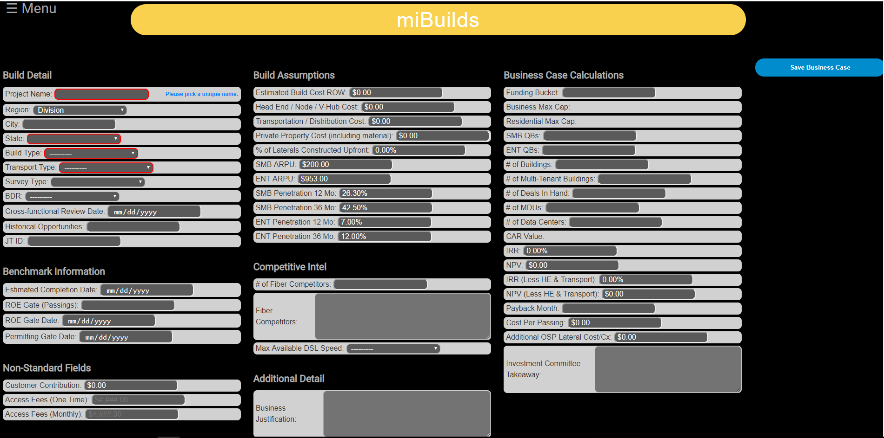

* Step 2: Region will be autopopulated based upon the user’s region. This will then limit the State select box to only applicable states.
* Step 3: Fill in the required fields and any other fields you would like at this point. Hit, “Save Business Case” button to create your business case.
* Step 4: The web application will either take you to the success screen if everything was filled out properly, or return you to the same screen and provide error messages as to what needs to be changed.

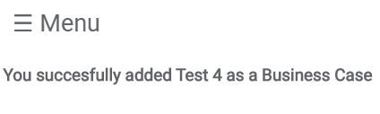

* Step 5: If the creation of the business case was successful, you will be taken to a subsequent screen with additional buttons where you can add additional items and receive your first calculations for the build.

### Spectrum Easy Button

* In Spectrum when you save your build design, the miBuilds easy button, becomes available to use.
* This feature saves you time by having the Spectrum design data flow through the back-end systems.
* Click on the miBuilds button, and miBuild web app automatically opens with your data loaded into the miBuilds web app.
* Make sure you save the Spectrum drawing with a unique name.
* Verify no prior duplicate business cases exist with this Spectrum job.

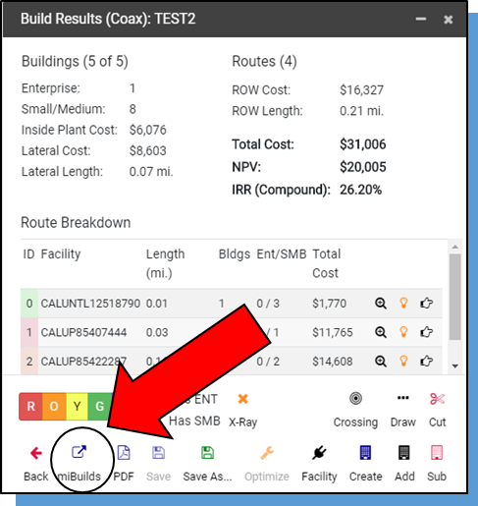

### Quick Calculator

* The quick calculator is a tool to gain an initial estimate to see if something meets IRR.
* On the home page, click on the hamburger menu top left corner to gain this view.

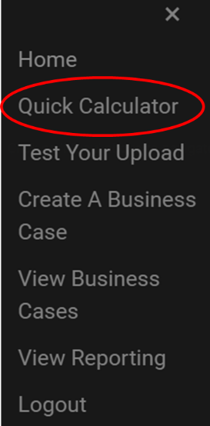

* Note: The calculator in the web version is more accurate than the old Excel version.

## Add, Upload, Edit, Delete Building(s)

### Add Building

* Step 1: Click on the “Buildings” button to navigate to the “Building Add” page.

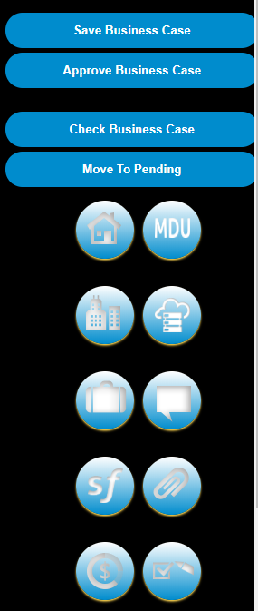

* Step 2 – Option 1: Enter in a MIP 2.0 Building ID in the “Building ID” field and the following fields will autopopulate: ***Address, City, State, Zip Code, Sellability Color Coax, Sellability Color Fiber, Building Type, and Dwelling Type***.

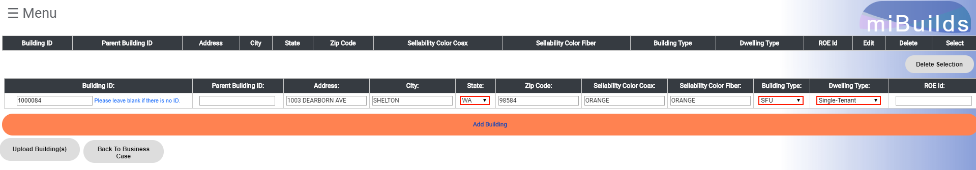

* Step 2 – Option 2: Leave the “Building ID” field blank (when not in MIP, Greenfield or another valid reason) and complete the following fields: ***Address, City, State, Zip Code, Sellability Color Coax, Sellability Color Fiber, Building Type, and Dwelling Type***.
* Step 3: Click “Add Building” below the form fields and the building will populate in the table above.

### Upload Building(s)

* Step 1: On the “Building Add” page select the “Upload Buildings” button below the forms fields. This will load the “Upload Buildings” page.



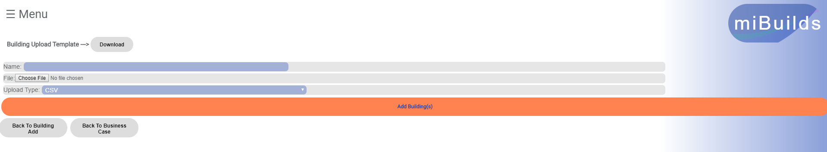

* Step 2: Click “Choose File” and you will be prompted to pick a file your from your computers directory. You have a couple of options here:
  + Option 1: You can use the template provided by the web application. The “Download” button at the top of this page will download that template for you. Once the CSV file download is complete, you can populate this file with MIP 2.0 Building IDs under the heading. **It is important to note that non numerical values, or IDs other than a Building ID will fail to upload any information.**
  + Option 2: You can use a Spectrum Build CSV export. This file will contain the correct heading and numerical values for Building IDs unless altered. If altered, please ensure that it follows the rules mentioned in Option 1 above.
  + Option 3: You can use your own CSV file as long as it follows the rules mentioned above and contains one of the valid headers mentioned below.
* Step 2 – Valid headers:
  + building_id
  + BUILDING_ID
  + MIP_BUILDING_ID
* Step 3: Provide a name for the uploaded file in the “Name” field if you would like, ensure that the file type is **.CSV** and that the “Upload Type” matches this. Then, click “Add Building(s)” below the form fields and you will be taken back to the “Building Add” page where you will see the buildings populated in the table above.



* If the file upload is not successful you will receive several different types of messages from the web application (see examples below):
  + Headers: You will receive a notification if the file doesn’t contain the correct possible headers. The correct headers will be provided to you for clarity.

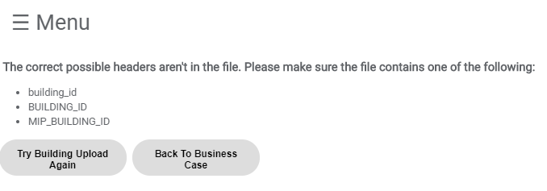

* + “These buildings were uploaded:”
    - If any of the Buildings IDs from the file were successfully uploaded, you will see this header with a list of the Building IDs that were uploaded.
    - If none of the Building IDs from the file were successfully uploaded, you will see:
      * “All buildings tied to a different build.”
      * “No buildings were uploaded.” The distinction here is that some of the buildings may not be tied to a different build but failed due to another reason (ex. Out of Region).
  + “These buildings were not uploaded:”
    - If there were Building IDs in the file that failed for another reason other than being tied to a different build, they will be listed here. Please double check that these are in the Region or that this is a correct ID.
  + “These buildings are tied to a different build:”
    - If Building IDs in the file are tied to a different build, this table will provide the Probuild Name in which they are tied to and the Building ID that failed this check.

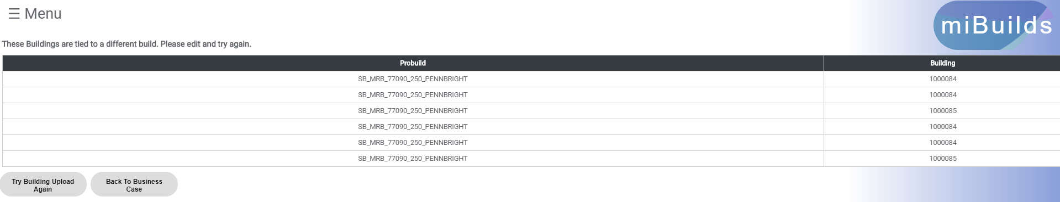

### Edit Building

* Step 1: On the “Building Add” page there is a table of buildings that are being used in the build. For each building in the table there is an “Edit” button. Click the “Edit Building” button for the building that you would like to edit and you will be taken to the “Building Edit” page.

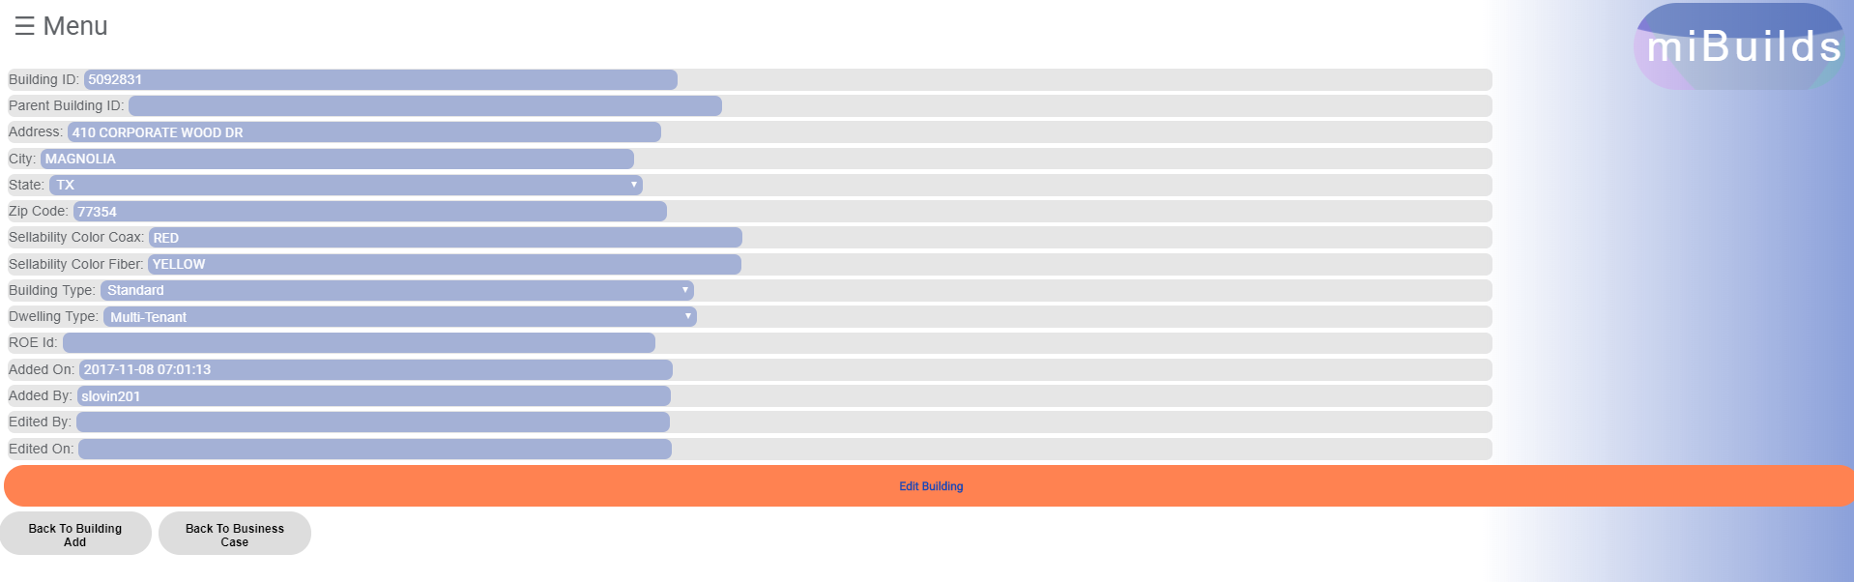

* Step 2: Alter any of the information about the building that you would like and click “Edit Building” to save your changes.
* Step 3: You will be taken back to the “Building Add” page after you have saved your changes.

### Delete Building(s)

* Delete Single Building
  + Step 1: On the “Building Add” page there is a table of buildings that are being used in the build. For each building in the table there is a “Delete” button. Click the “Delete” button and you will receive a prompt.

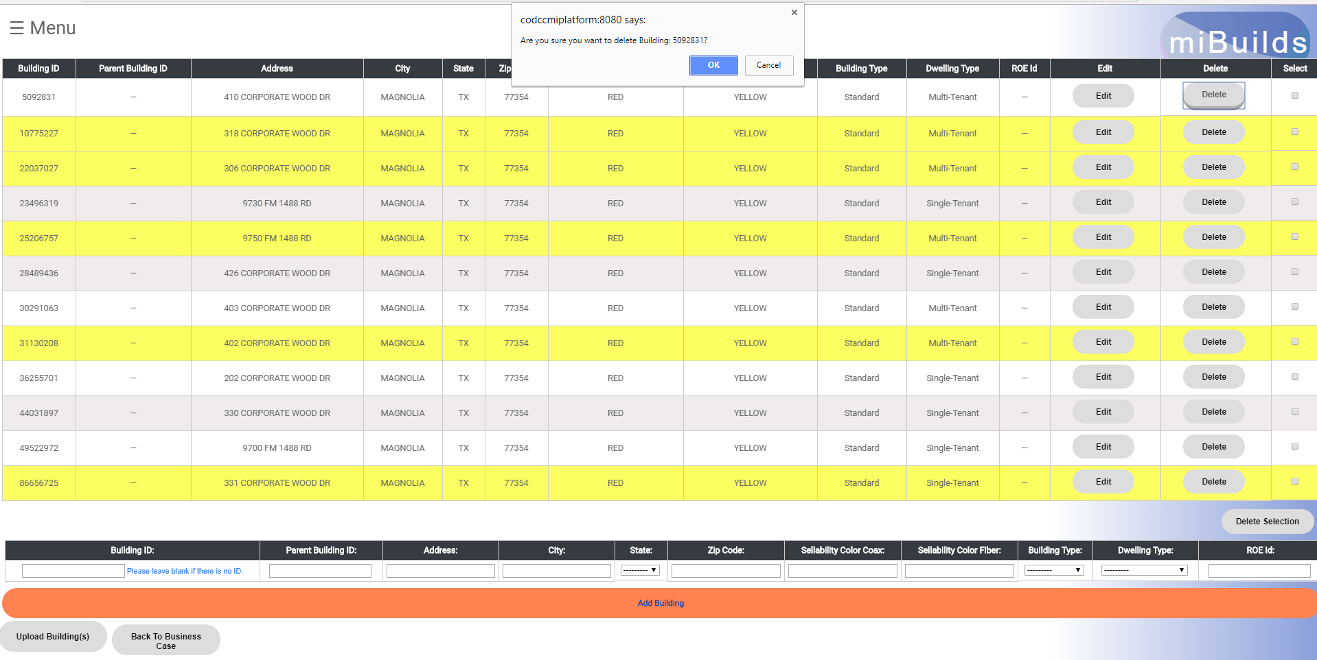

* + Step 2 – Option 1: On the prompt at the top of the screen, click “OK”. This will delete the building, give you a success message confirming the deleted building (click “OK”) and reload the page with the building absent from the table.



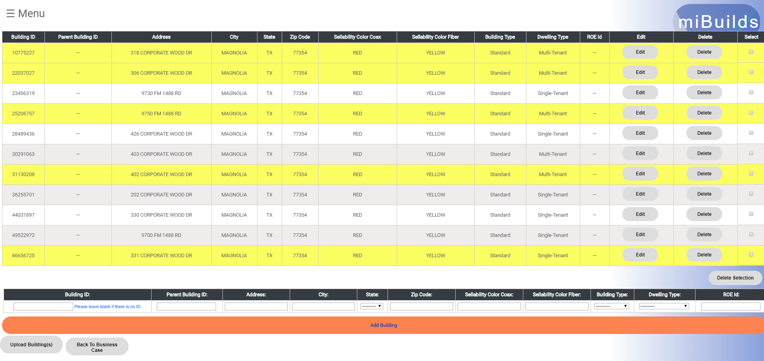

* + Step 2 – Option 2: On the prompt at the top of the screen, click “Cancel.” This will cancel the delete, the prompt will disappear and you will not have deleted a building.
* Delete Multiple Buildings
  + Step 1: On “Building Add” page there is a table of buildings that are being used in the build. For each building in the table there is a “Select” checkbox. Select the checkbox for each building that you would like to delete. After you have selected the buildings you would like to delete, click the “Delete Seleciton” button and you will receive a prompt.

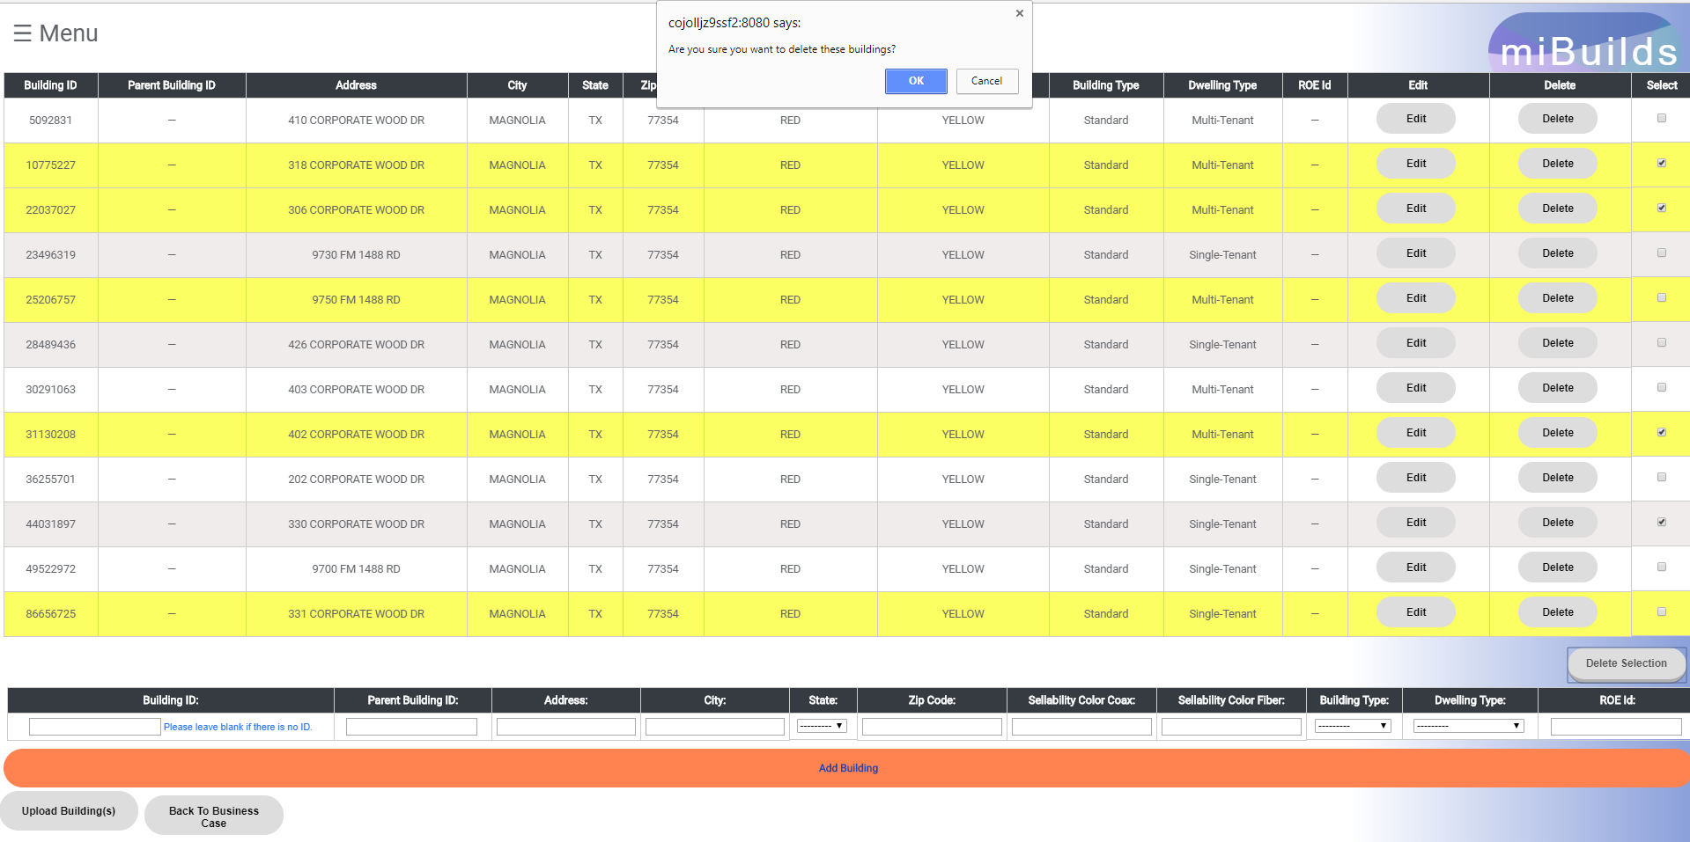

* + Step 2 – Option 1: On the first prompt at the top of the screen, click “OK” if you would like to delete the buildings. This will lead to another prompt that lists the Building IDs you will be deleting. Click “Ok" here to continue deleting the buildings. Next, you will receive a success message confirming the deleted buildings (click “OK”) and the page will reload with the buildings absent from the table.

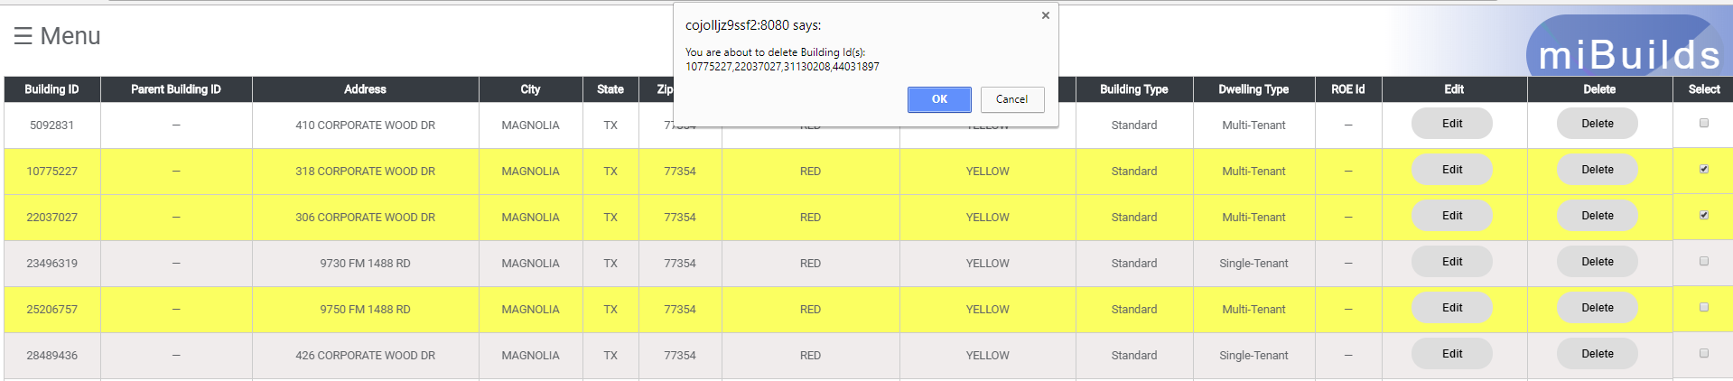



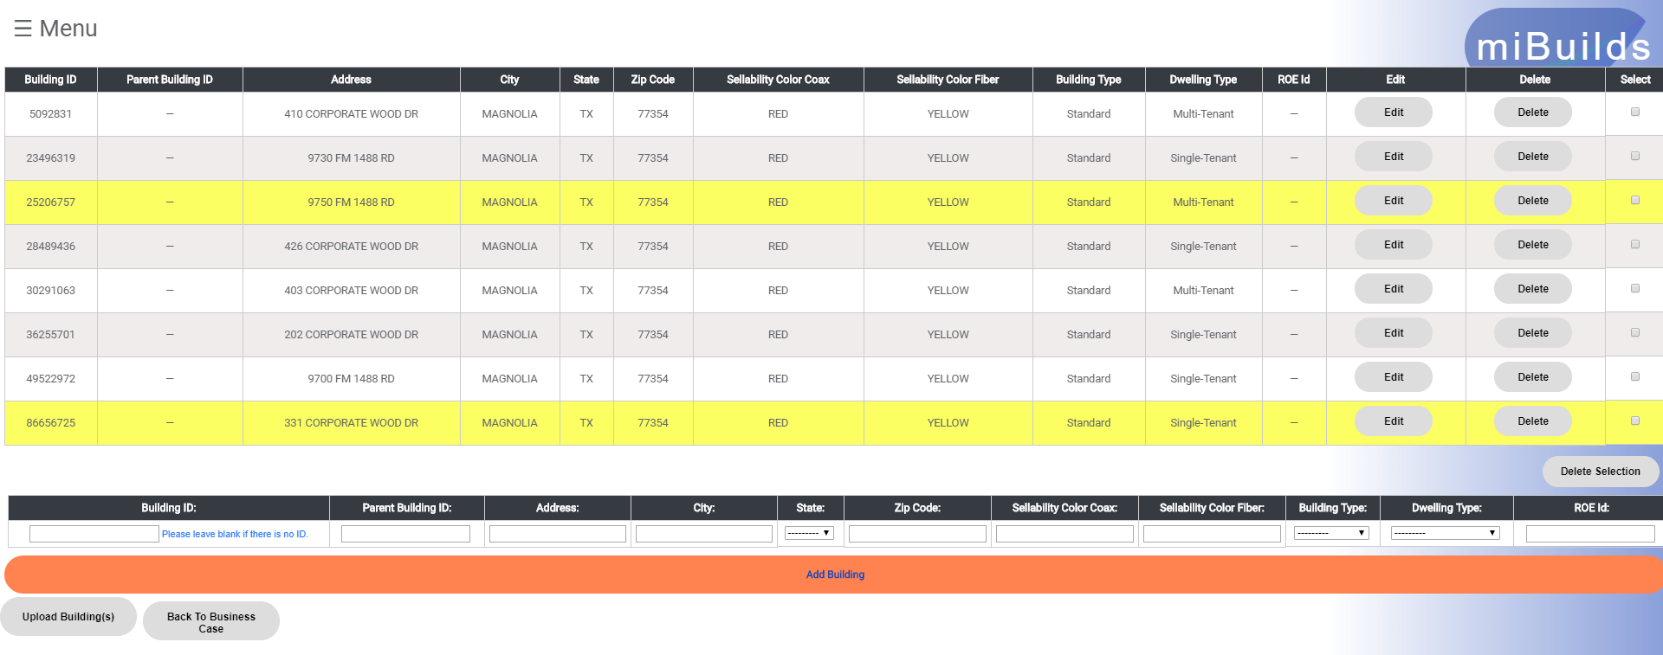

* + Step 2 – Option 2: On the prompt at the top of the screen, click “Cancel” at any point. This will cancel the delete, the prompt will disappear and you will not have deleted a building.

## Add Business(es)

### Add Business

* Step 1: Click on the “Businesses” button to navigate to the “Business Add” page.

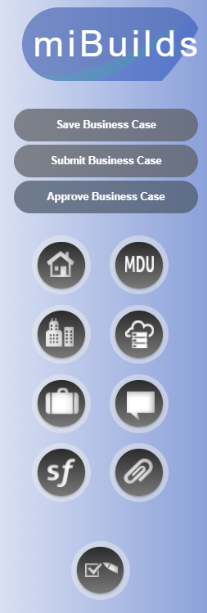

* Step 2 – Option 1: Enter in a valid MIP 2.0 Business ID in the “Business ID” field and the following fields will autopopulate: ***Building Id, Business Name, Address 1, Address 2Sellability Color Coax, Sellability Color Fiber, and Segment Type***.

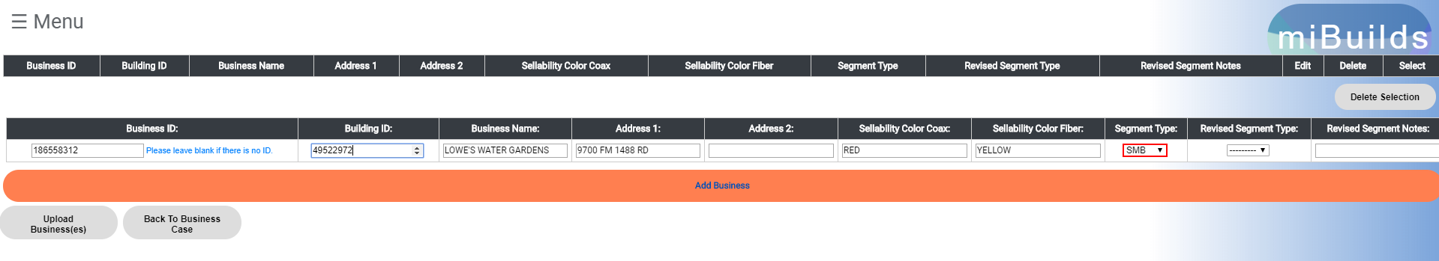

* Step 2 – Option 2: Leave the “Business ID” field blank (when not in MIP, Greenfield or another valid reason) and complete the following fields (at minimum): ***Building Id, Business Name, Address 1, Address 2Sellability Color Coax, Sellability Color Fiber, and Segment Type***.
* Step 3: Click “Add Building” below the form fields and the building will populate in the table above.

### ROE ID Entry

* The ability to tie a Right of Entry (ROE) ID to a business and build allows the Division Team to properly report on ROE’s where there is limited data.
* This applies to businesses that can’t be tied to a building via a Building ID (Greenfields or a gap in MIP data).
* Benefits of this feature include: Improves data accuracy in reporting, fills in gaps when knowledge is limited, and helps identify which addresses need an ROE.
* How do I use this feature?
  + In miBuilds, when manually entering a business, there is a field called ROE ID that can be utilized. Please use the Pramata Number when entering data in this field.
  + When uploading a Greenfield template, simply enter the Pramata Number in the ROE_ID field. This will transfer to the business case.
  + When using the Easy button or uploading a list of Building ID’s, the ROE ID field will populate a value where we have a matching Pramata Number on file.
  + At any point, before approval, users can go back to the business case to populate the ROE ID field. After approval, limited users can populate the ROE ID field.
* Are there validations in place?
  + When manually entering a business, an alert message will appear only if the value entered in the ROE ID field doesn’t match a valid Pramata Number that we have on file.
  + In the table of businesses, the ROE ID field will be red if the value is NULL or if the value doesn’t match a valid Pramata Number that we have on file.

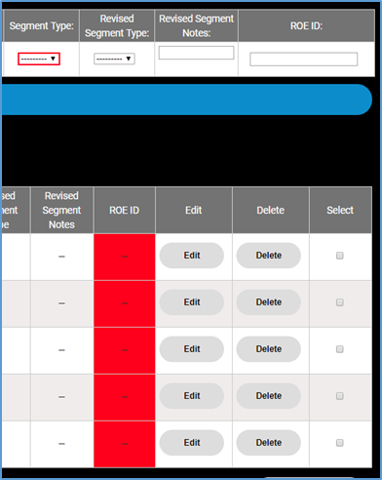

### Upload Business(es)

* Step 1: On the “Business Add” page select the “Upload Business(es)” button below the forms fields. This will load the “Upload Buildings” page.



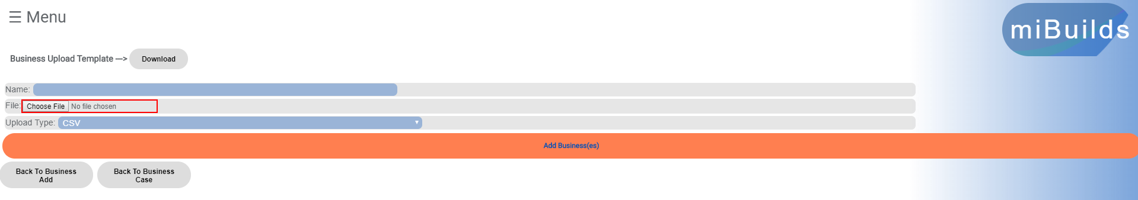

* Step 2: Click “Choose File” and you will be prompted to pick a file your from your computers directory. You have a couple of options here:
  + Option 1: You can use the template provided by the web application. The “Download” button at the top of this page will download that template for you. Once the CSV file download is complete, you can populate this file with valid MIP 2.0 Business IDs under the heading. **It is important to note that non numerical values, or IDs other than a Business ID will fail to upload any information.**
  + Option 2: You can use a Spectrum Build CSV export. This file will contain the correct heading and numerical values for Business IDs unless altered. If altered, please ensure that it follows the rules mentioned in Option 1 above.
  + Option 3: You can use your own CSV file as long as it follows the rules mentioned above and contains one of the valid headers mentioned below.
* Step 2 – Valid headers:
  + business_id
  + BUSINESS_ID
  + MIP_QB_ID
* Step 3: Provide a name for the uploaded file in the “Name” field if you would like, ensure that the file type is **.CSV** and that the “Upload Type” matches this. Then, click “Add Business(es)” below the form fields and you will be taken back to the “Business Add” page where you will see the businesses populated in the table above.

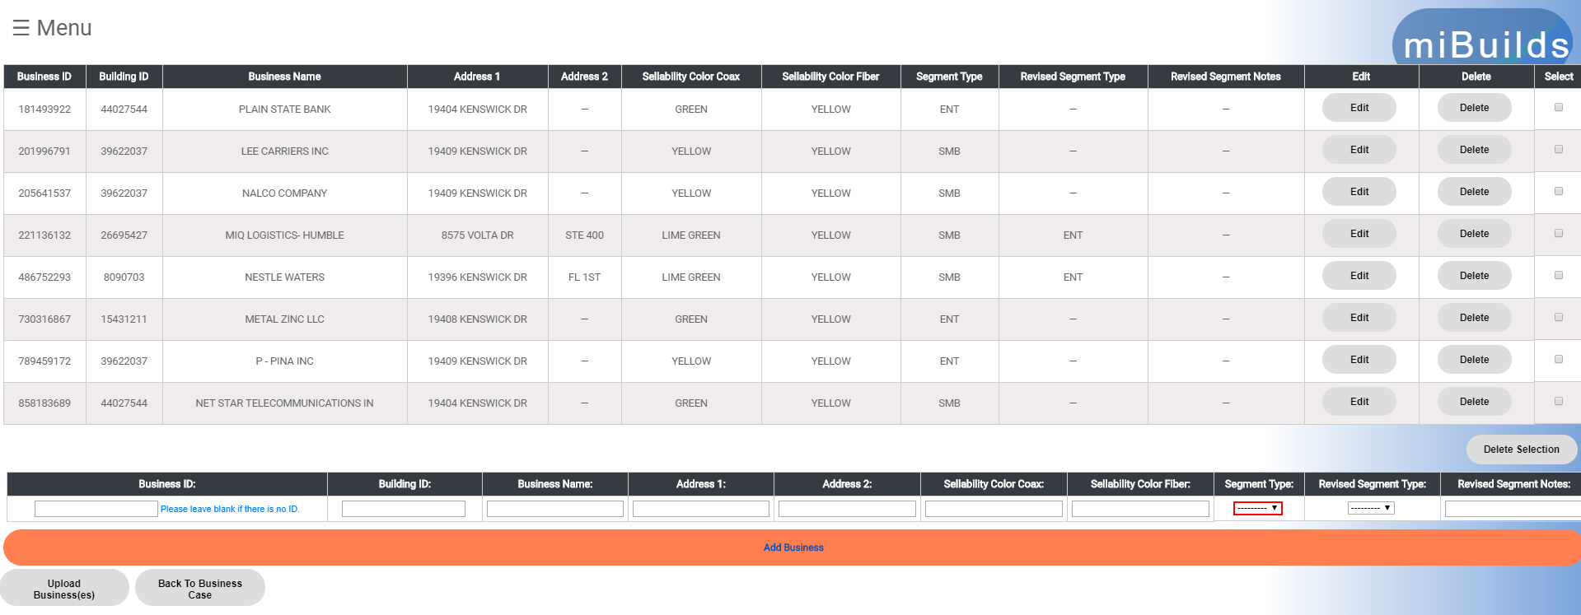

* If the file upload is not successful you will receive several different types of messages from the web application (see examples below):
  + Headers: You will receive a notification if the file doesn’t contain the correct possible headers. The correct headers will be provided to you for clarity.

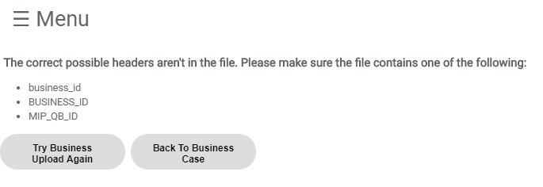

* + “These businesses were uploaded:”
    - If any of the Business IDs from the file were successfully uploaded, you will see this header with a list of the Business IDs that were uploaded
    - If none of the Business IDs from the file were successfully uploaded, you will see:
      * “All businesses tied to a different build.”
      * “No businesses were uploaded.” The distinction here is that some of the businesses may not be tied to a different build but failed due to another reason (ex. Out of Region)
  + “These businesses were not uploaded:”
    - If there were Business IDs in the file that failed for another reason other than being tied to a different build, they will be listed here. Please double check that these are in the Region or that this is a correct ID
  + “These businesses are tied to a different build:”
    - If Business IDs in the file are tied to a different build, this table will provide the Probuild Name in which they are tied to and the Business ID that failed this check.

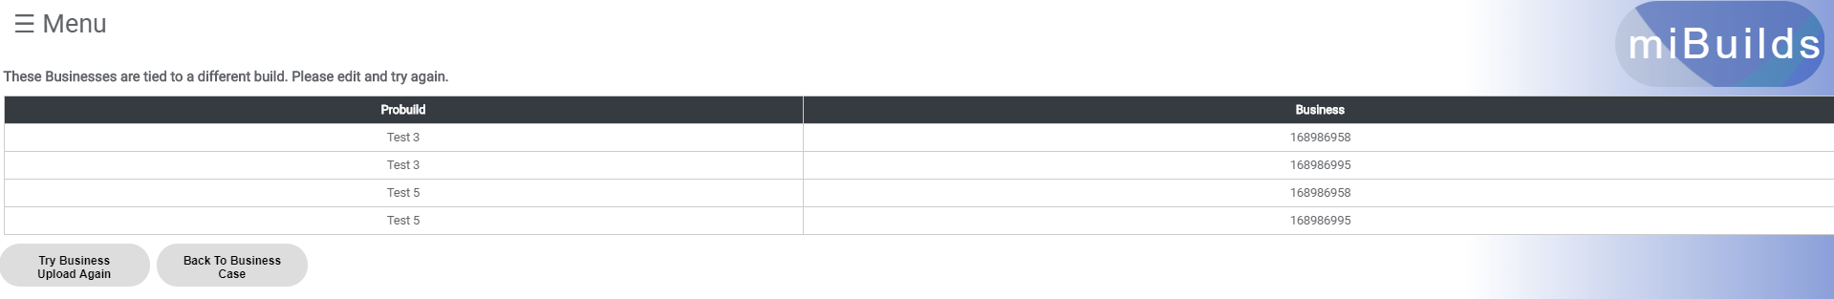

### Edit Business

* Step 1: On the “Business Add” page there is a table of buildings that are being used in the build. For each building in the table there is an “Edit” button. Click the “Edit Business” button for the building that you would like to edit and you will be taken to the “Business Edit” page.

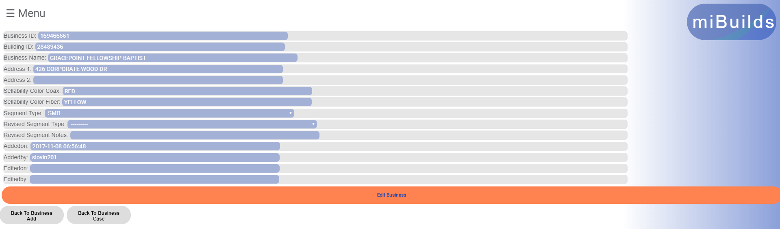

* Step 2: Alter any of the information about the business that you would like and click “Edit Business” to save your changes.
* Step 3: You will be taken back to the “Business Add” page after you have saved your changes.

### Delete Business(es)

* Delete Single Business
  + Step 1: On the “Business Add” page there is a table of businesses that are being used in the build. For each business in the table there is a “Delete” button. Click the “Delete” button and you will receive a prompt.

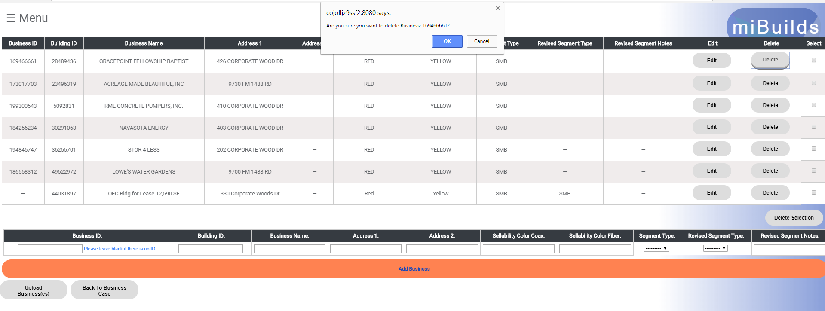

* + Step 2 – Option 1: On the prompt at the top of the screen, click “OK”. This will delete the business, give you a success message confirming the deleted business (click “OK”) and reload the page with the business absent from the table.



* + Step 2 – Option 2: On the prompt at the top of the screen, click “Cancel.” This will cancel the delete, the prompt will disappear and you will not have deleted a business.
* Delete Multiple Businesses
  + Step 1: On “Business Add” page there is a table of businesses that are being used in the build. For each building in the table there is a “Select” checkbox. Select the checkbox for each business that you would like to delete. After you have selected the businesses you would like to delete, click the “Delete Seleciton” button and you will receive a prompt.

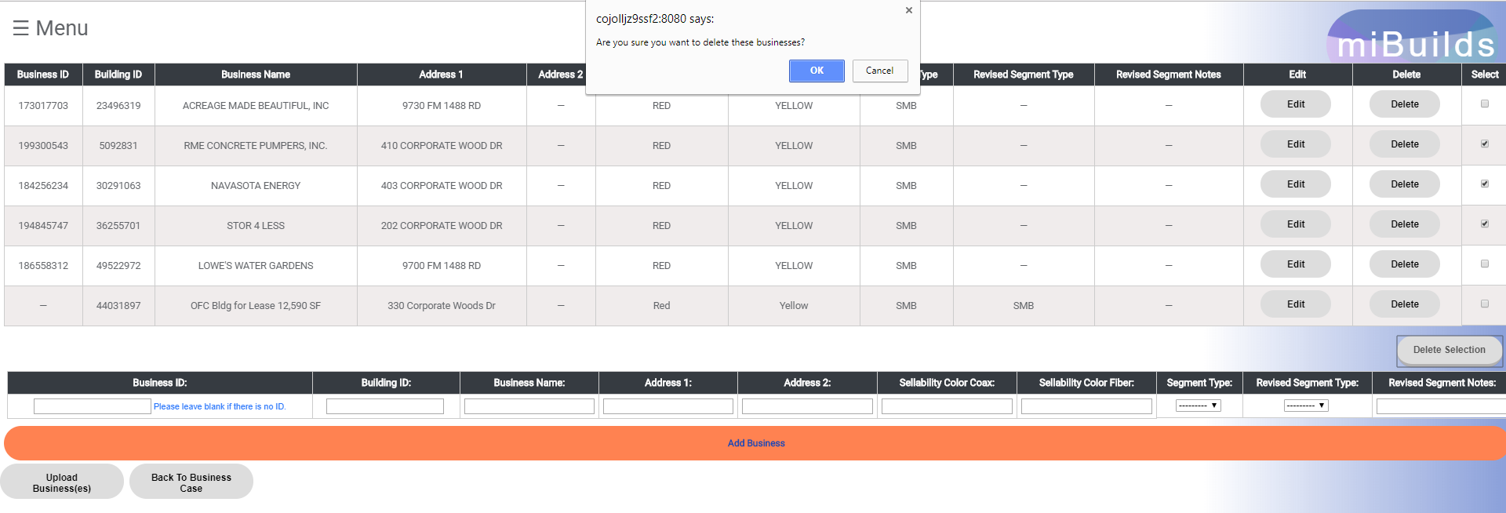

* + Step 2 – Option 1: On the first prompt at the top of the screen, click “OK” if you would like to delete the businesses. This will lead to another prompt that lists the Business IDs you will be deleting. Click “Ok" here to continue deleting the businesses. Next, you will receive a success message confirming the deleted buildings (click “OK”) and the page will reload with the businesses absent from the table.

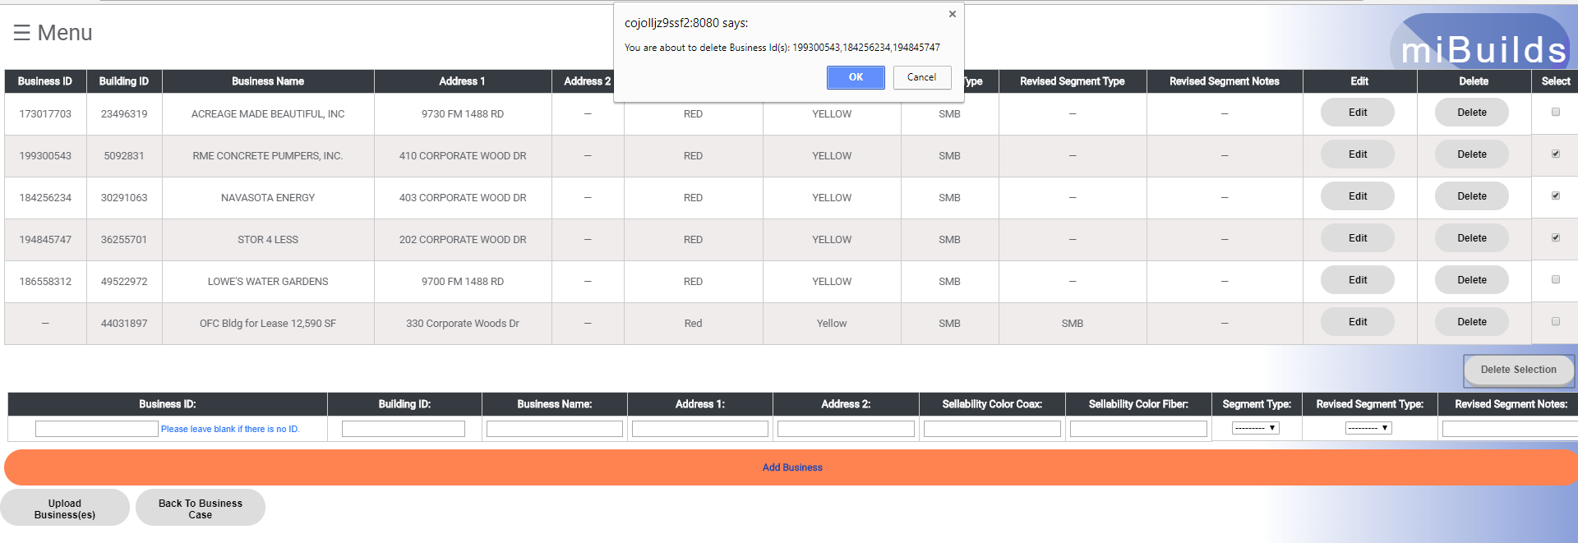

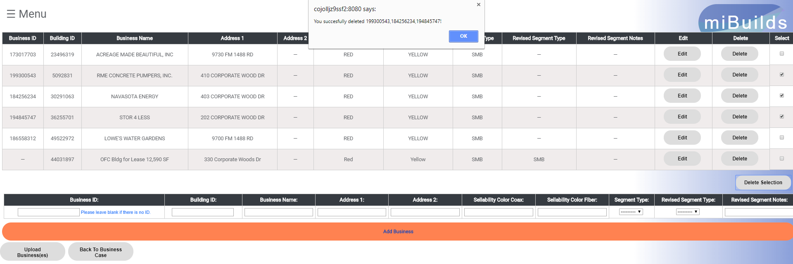

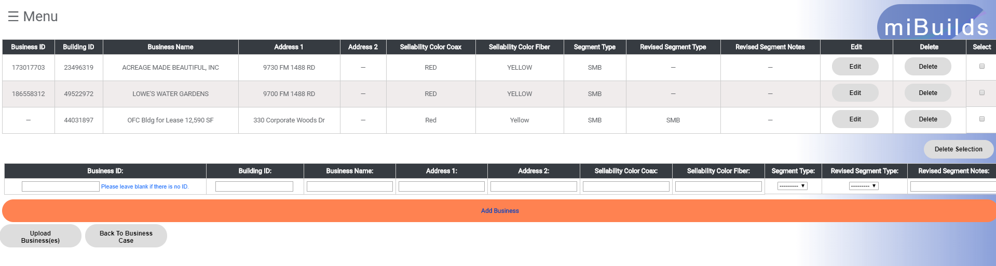

* + Step 2 – Option 2: On the prompt at the top of the screen, click “Cancel” at any point. This will cancel the delete, the prompt will disappear and you will not have deleted a building.

## Add Deal In Hand(s)

* Placeholder

## Add MDU(s)

### Add MDU

* 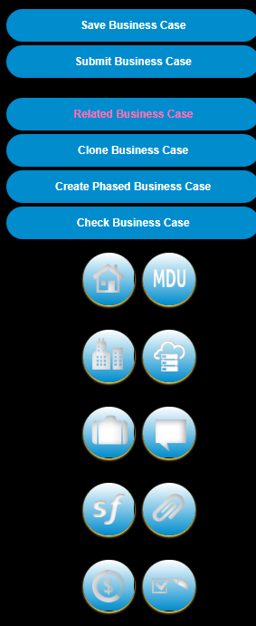
* Step 1: Click on the “MDU” button to navigate to the “MDU Add” page.
* Step 2 – Select valid options from the drop downs: **Build Type, Current Service and Contract Term**. The following fields will autopopulate values (base assumptions): ***Video/Data/Voice Penetration, Video/Data/Voice ARPU, Opex Load, Upfront Door Fee, Inside Wiring, Converter, Modem, EMTA, Commission and Penetration Ramp***. Additionally, the fields ***Total Buildings*** and ***Total Units*** are required to complete the necessary revenue calculation for the MDU. Completing these fields will autopopulate the ***Video/Data/Voice Subscriber Target*** fields (a calculation of **Total Units * Penetration**). The Subscriber Target fields are an estimate of the RGUs needed to drive achieve calculated revenue figures.

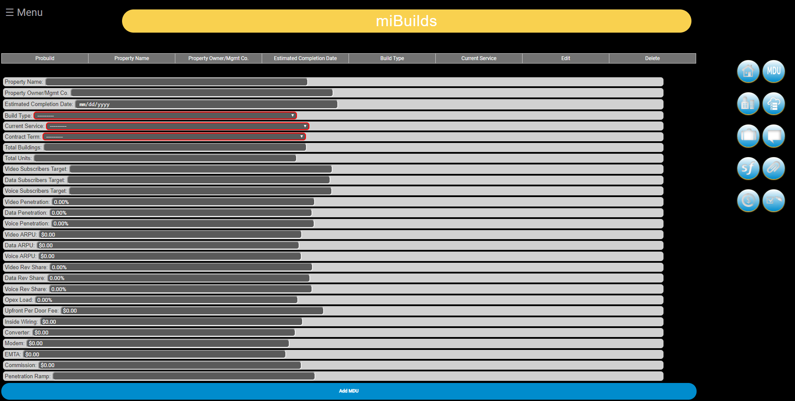

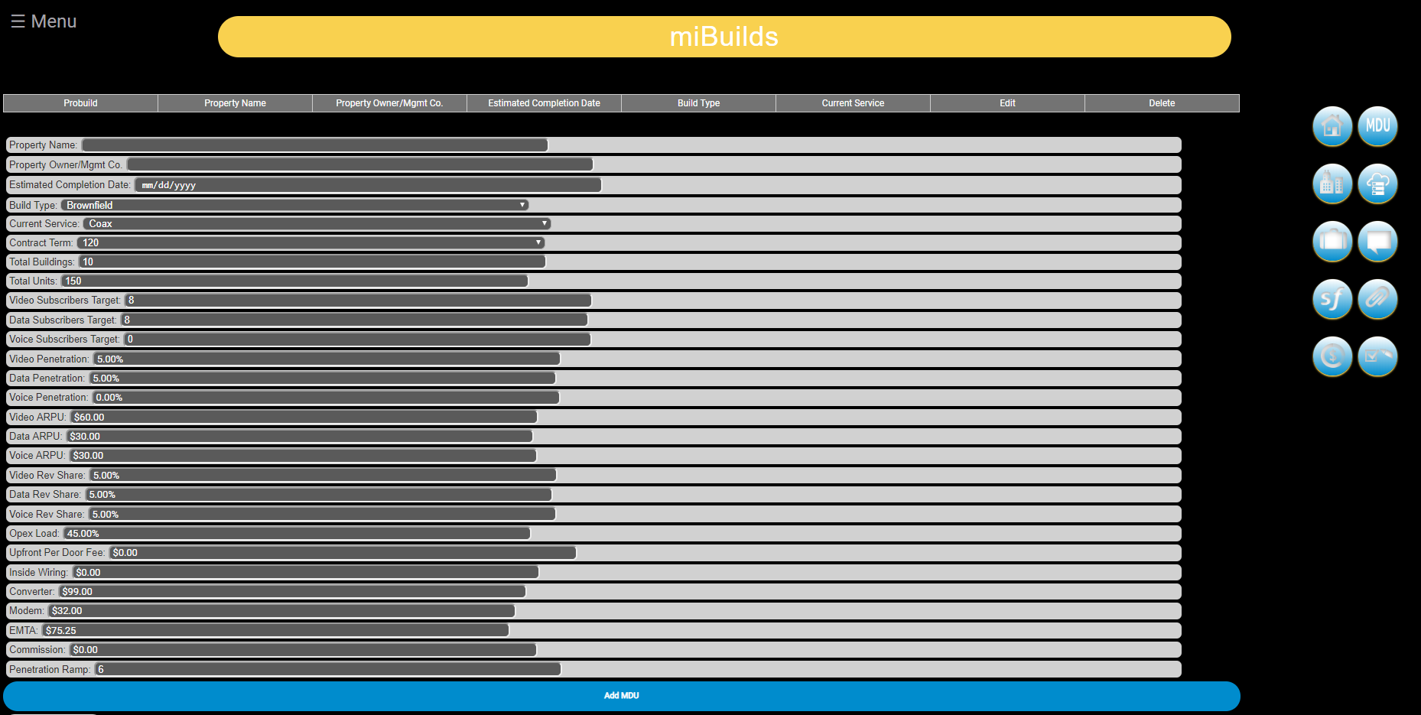

* Step 3: Adjust base assumptions where needed (hopefully after you have consulted with your local MDU Team).
* Step 4: Click “Add MDU” below the form fields and the MDU will populate in the table above.

### Edit MDU

* Step 1: On the “MDU Add” page there is a table of MDUs that are being used in the build. For each MDU in the table there is an “Edit” button. Click the “Edit” button for the desired MDU that you would like to edit. You will then be taken to the “MDU Edit” page.

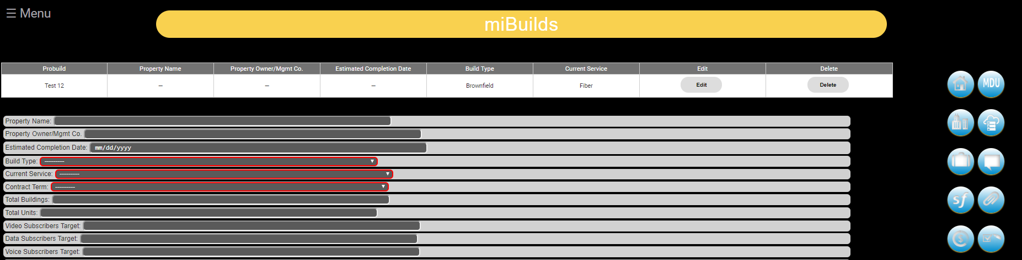

* Step 2: Alter any of the information about the MDU that you would like and click “Edit MDU” to save your changes.

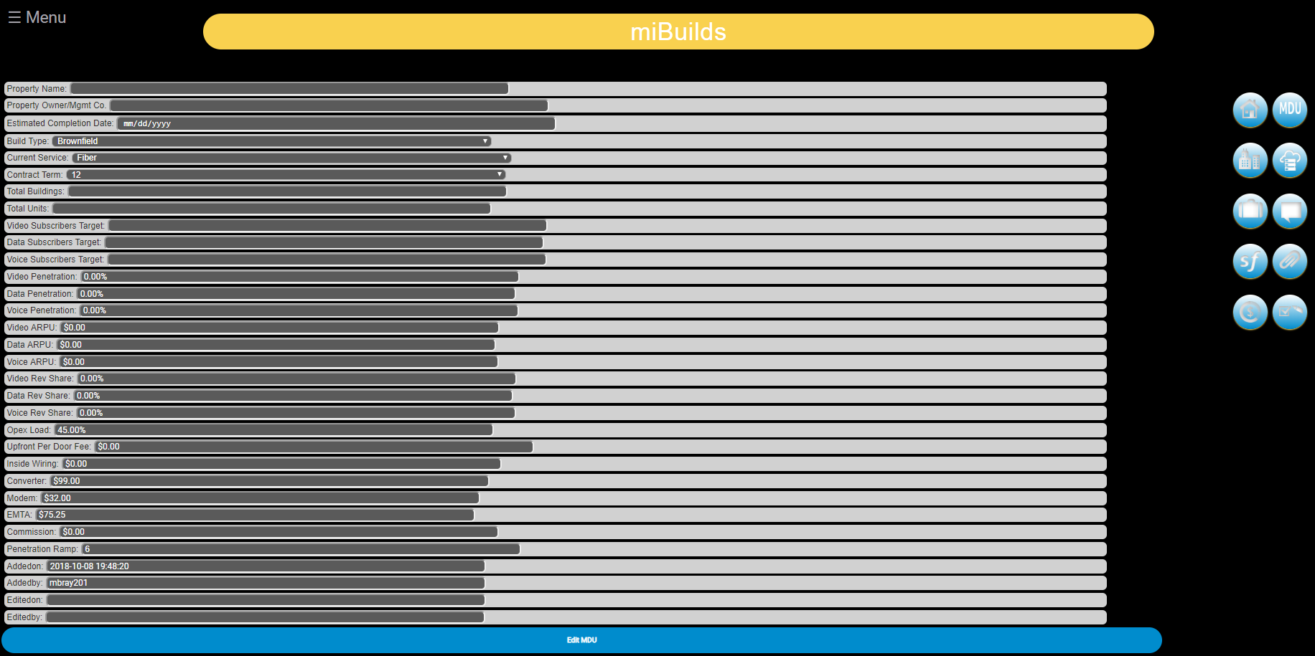

* Step 3: You will be taken back to the “MDU Add” page after you have saved your changes.

### Delete MDU

* Delete Single MDU
  + Step 1: On the “MDU Add” page there is a table of MDUs that are being used in the build. For each MDU in the table there is a “Delete” button. Click the “Delete” button and you will receive a prompt.

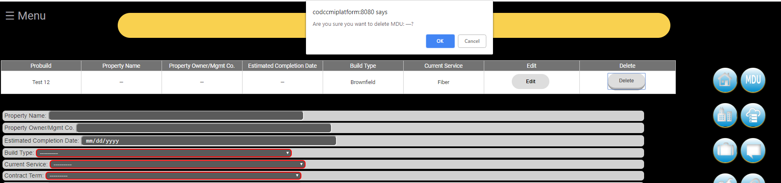

* + Step 2 – Option 1: On the prompt at the top of the screen, click “OK”. This will delete the MDU, give you a success message confirming the deleted MDU (click “OK”) and reload the page with the MDU absent from the table.

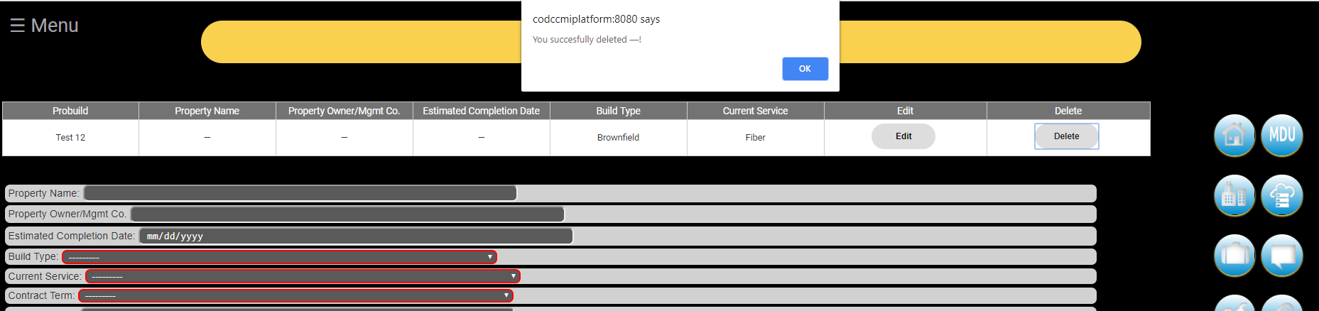

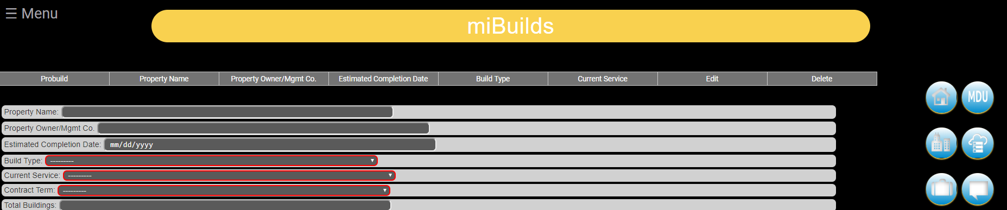

* + Step 2 – Option 2: On the prompt at the top of the screen, click “Cancel.” This will cancel the delete, the prompt will disappear and you will not have deleted a business.
* Delete Multiple MDUs
  + Placeholder

## Add Data Center(s)

### Add Data Center

* Step 1: Click on the “Data Center” button to navigate to the “Data Center Add” page.



* Step 2 – Select valid options from the drop downs: **Size and Equipment Type**. The following fields will autopopulate values (base assumptions): ***Rack, Colo Fee, Connect Costs, MRR/Circuit, Equipment Cost, Power, Tech Opex Load and Year 1- Year 5***.

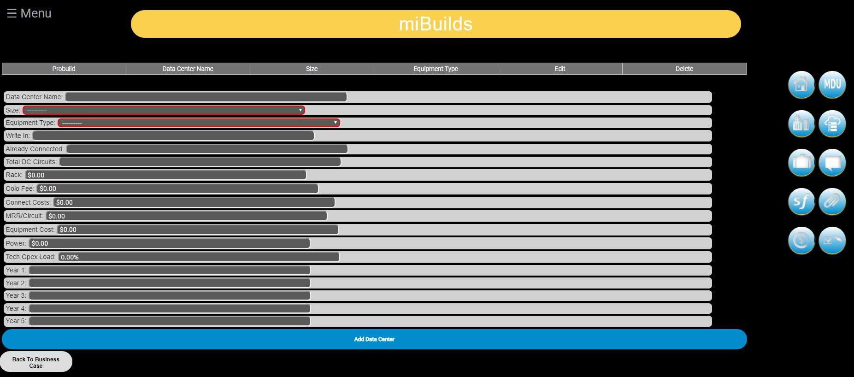

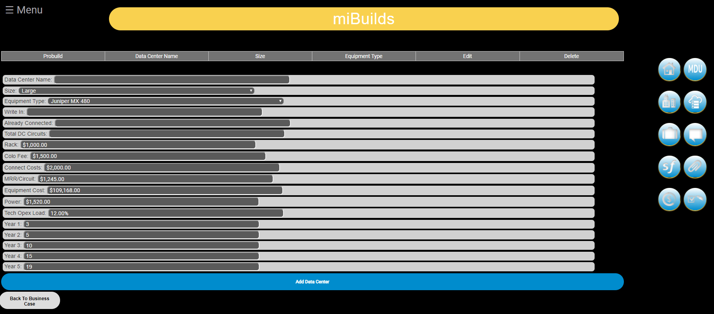

* Step 3: Adjust base assumptions where needed (hopefully after you have consulted with your local Sales Engineering Team).
* Step 4: Click “Add Data Center” below the form fields and the Data Center will populate in the table above.



### Edit Data Center

* Step 1: On the “Data Center Add” page there is a table of Data Centers that are being used in the build. For each Data Center in the table there is an “Edit” button. Click the “Edit” button for the desired Data Center that you would like to edit. You will then be taken to the “Data Center Edit” page.

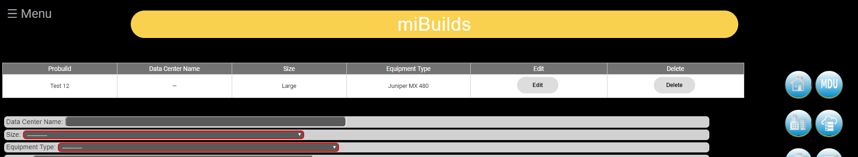

* Step 2: Alter any of the information about the Data Center that you would like and click “Edit Data Center” to save your changes.

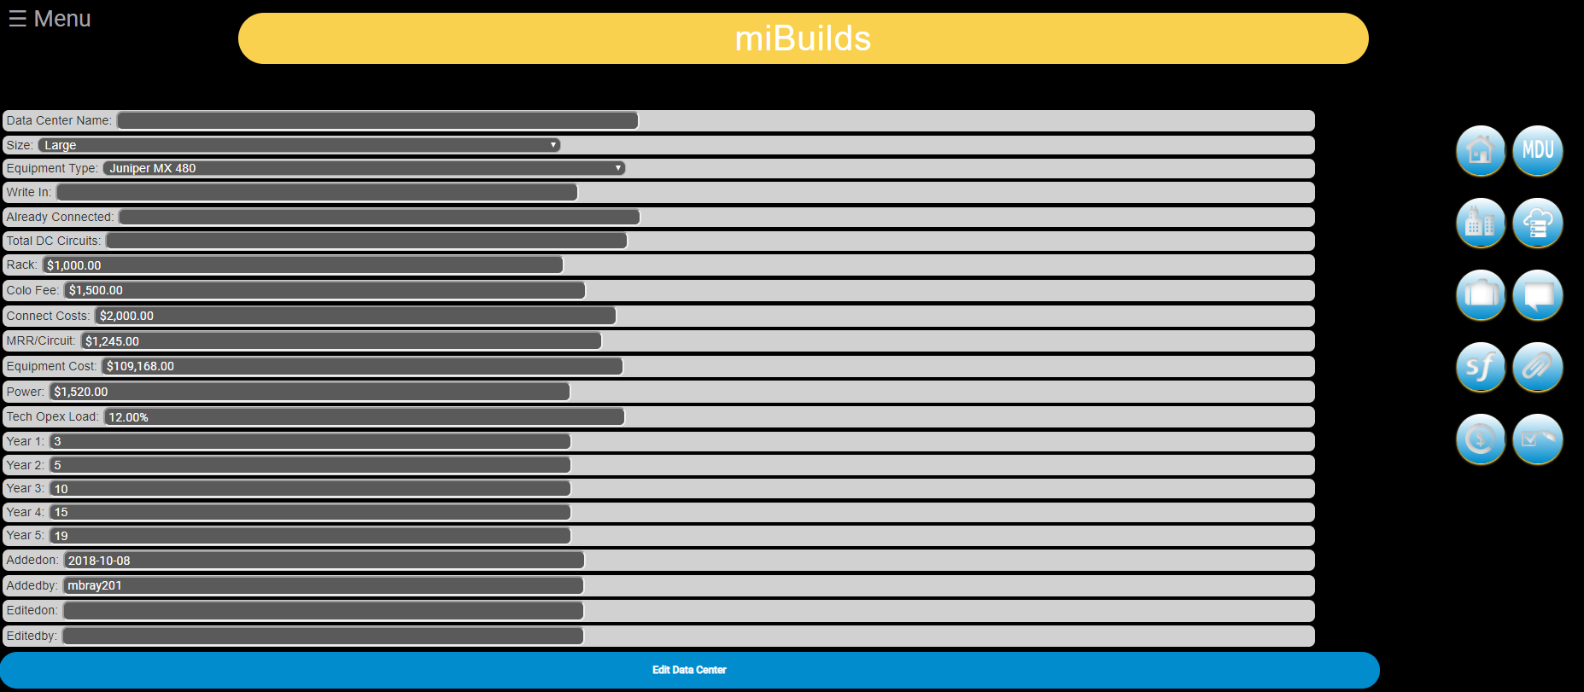

* Step 3: You will be taken back to the “Data Center Add” page after you have saved your changes.

### Delete Data Center(s)

* Delete Single Data Center
  + Step 1: On the “Data Center Add” page there is a table of Data Centers that are being used in the build. For each Data Center in the table there is a “Delete” button. Click the “Delete” button and you will receive a prompt.

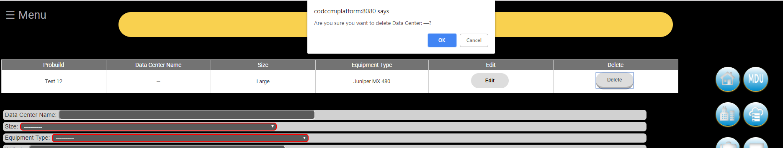

* + Step 2 – Option 1: On the prompt at the top of the screen, click “OK”. This will delete the Data Center, give you a success message confirming the deleted Data Center (click “OK”) and reload the page with the Data Center absent from the table.

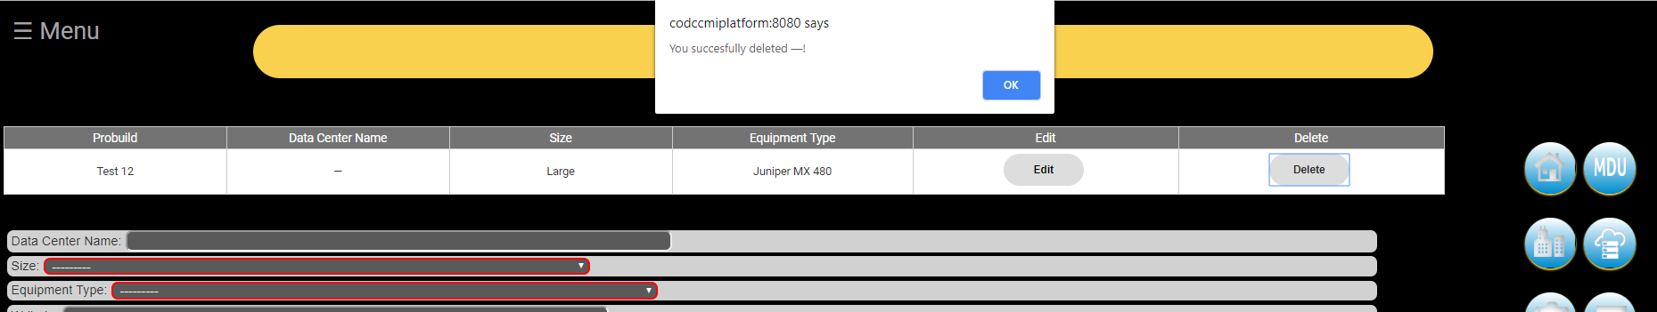

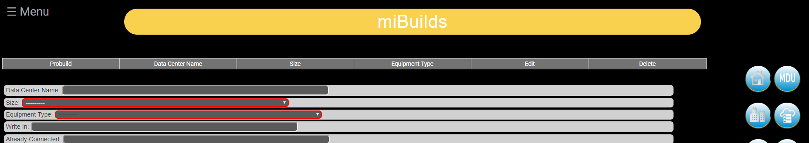

* + Step 2 – Option 2: On the prompt at the top of the screen, click “Cancel.” This will cancel the delete, the prompt will disappear and you will not have deleted a business.
* Delete Multiple Data Centers
  + Placeholder

## Multiphase Business Cases

### Description

* This new feature accommodates large, long-term construction projects by linking build phases together in one cohesive package.

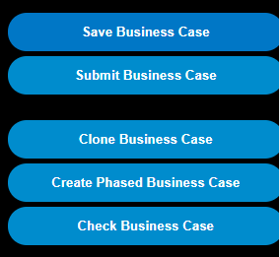

### Benefits

* Creates an efficient game plan to building out a large area.
* Improves reporting and overall plan economics with parent / child business cases.
* Matches construction’s approach for executing on large, long-term construction projects.
* Individual child cases are performance drivers, not parent.

### Process

Create

* From existing business case, go to top right corner, click on create phased business case.
* This will redirect you to the new child business case.
* On the build name, scroll to the far right and you should see “phase 1”.
* You will notice the created phased business case button has disappeared.
* Go back to the Parent business case to create an additional phase.
* When you create a phase, all data from the Parent business case will be automatically copied to the child business cases so it saves you time. Downward compatible. Some options for use include:
  + Create a shell business case or
  + Create a Parent with everything in it, and then edit.
  + Enter the buildings and businesses into their specific phase.

Edit

* The same features and functionality are available for child business cases.
* On the Parent business case, the child jobs roll up. To make edits you must do it in the child jobs.
* A build cannot be “un-phased” so to remove it, it must be deleted.
* Child buildings and businesses do not get posted into the Parent business case. Not upward compatible.

Search

* You can always search by the original business case name or phase.

Approve

* The child jobs are submitted individually to be approved individually.

## Exception Processes

### Caring for MDUs

* + On the summary page and match the building / business tabs.
  + In order to account for MDU Revenue Actuals, you need a building ID for each MDU building. No longer include the # of buildings from the MDU tab in the total buildings on the summary page. Instead, The user to input the buildings on the Buildings tab and reflect only these buildings on the summary page.

### Caring for address ranges.

* + Example 1 building that has a range of: 100-110 Main Street USA. 100, 102, 104, 106, 108, 110. This is one lateral, not 6. Parent child business doesn’t recognize the difference so how to you show the front page as 1 building?
  + Initally you enter 100 Main Street. Issue the order. Then after the order is issued, go back in to miBuilds, and you add the buildings tab, 102, 104, 106, 108 and 110 and the corresponding building IDs. Then match them up with the businesses on the following page to go from yellow to white.

# Submit a Business Case

## Submitting

* When a business case is ready for review and approval, the Business Development person clicks on the submit button.



## Review Business Case

* An automated email is sent to the Region Lead or Division Lead to open the submitted business case and review.
* Overall Flow
  + If the CAR value is <$200,000, the Region leadership team will review the business case
  + If the total CAR value total is >$200,000, the Division leadership team reviews the business case
* Attributes of Good Business Cases and Builds are listed in the Business Development Playbook.
* If the business case requires additional development, the Lead can reject the business case and send it back to the originator for adjustments.

# Approve a Business Case

## Leads

* When the lead decides the business case is ready, he or she clicks on the approve button.
* Upon approved, an automated email to goes to the Region and orDivision finance and Construction key contacts as notification. There is variance by Region as who who receives the email notification.
  + To make changes to the approval distribiution list please contact the miBuilds Support team



* Once a business case is approved, the costs will never change in the web app, but they may change in reality.

### Regional Approval

* Received when a business case’s ***$ Estimated Total Expenditure*** is less than $200,000
* The email will contain:
  + Excel Attachment – importatnt summary information for distribution
    - Financial Summary:



* + - Building Summary:

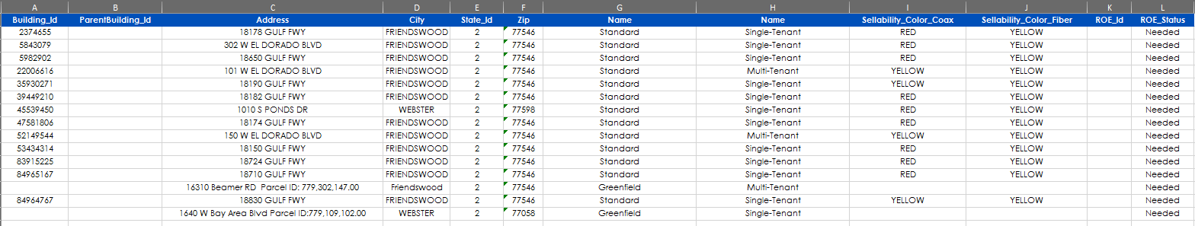

* + - Business Summary:

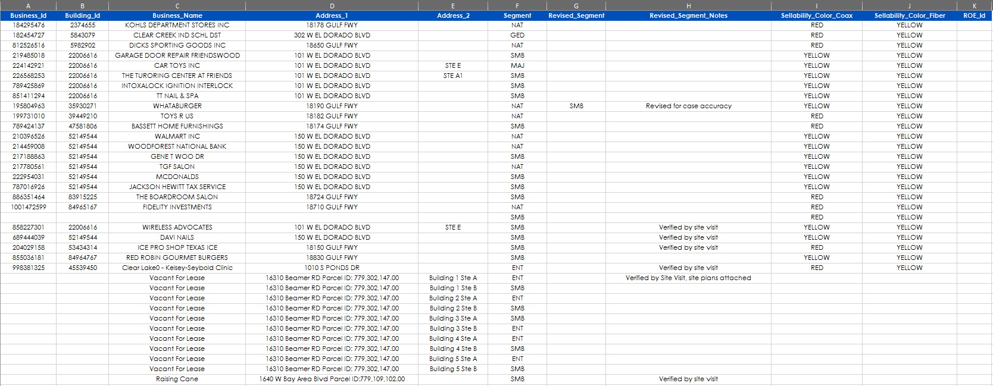

* + Key Information – related to the approval process of the business case
    - Business Case Name: the name of the business case
    - Business Case Link: link to business case in miBuilds web application
    - Approved By: NT Login of user that approved the business case
    - Approved On: the date the business case was approved
    - Submitted By: NT Login of user that submitted the business case
    - Submitted On: the date the business case was submitted
    - JT Id: the Construction Job Tracker Id associated to the business case
    - NOTE: JT number must be the ROW build.

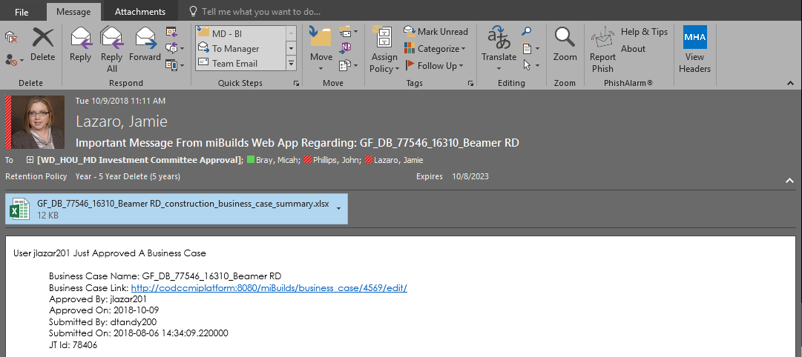

### Division Approval

* The content provided is similar to Region information above.

## How to Edit post approval

* Business cases can be edited after approval.
* Information on the tabs can be modified like adding or deleting Buildings and businesses
* If the main summary page needs changing, the Lead approver places the business case into pending status so changes can be entered. Once completed, the BDR resubmits the business case to be reviewed and approved.

# Notes, Emails and Additional Features

## Add Note(s)

* Placeholder

## Table Sorting

* Any HTML table in the web application can be sorted by a selected header. Simply click the header that you would like to sort by and the web application will sort the table by ascending order by the column. Click the header again and the web application will sort the table in descending order by the column.

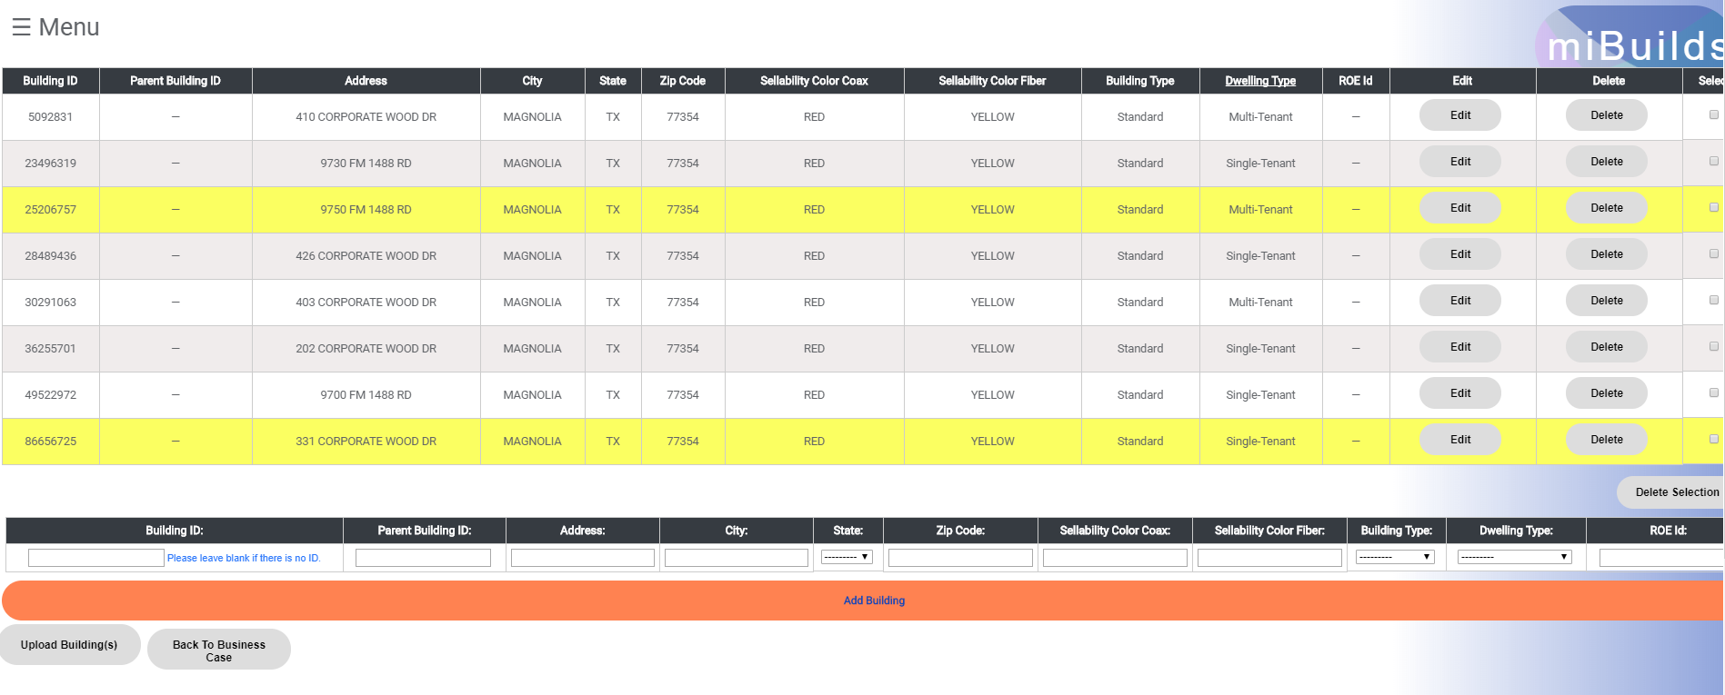

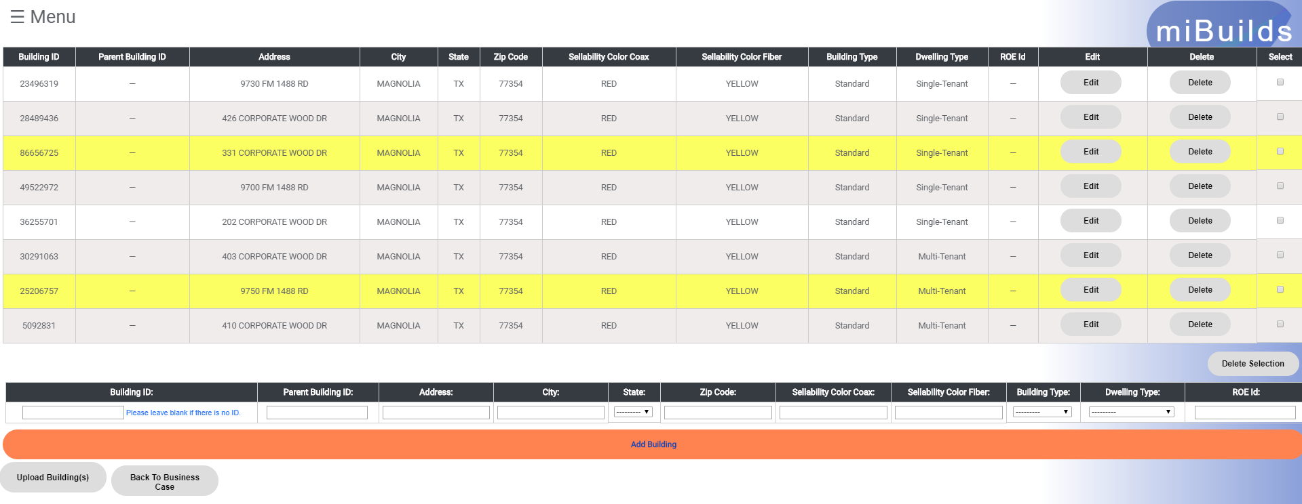

# Reporting

## Add Data Center(s)

* Placeholder
* [Micah – we have a report section in 3.9. Do we need this section?]

# User Guide Governance

## Change Control

* The miBuilds Web App User Guide is a living document and will continue to be updated as new operational impacts and best practices are identified. Send recommendation additions to [WD Market Development Operations](mailto:_WD_ALL_MarketDevelopmentQuestions_and_Answers_@cable.comcast.com?subject=WD%20Probuild%20Playbook).
* West Division Regions are expected to create Business Cases as detailed within this user guide.

|  |  |  |  |
| --- | --- | --- | --- |
| Version | Description | Date | Added By |
| v1 | Creation | 2017-11 | Micah Bray |
| V1.2 | Additions and modifications | 2018-10 | Micah Bray & Alison Lytle |

# Appendix

## Business Development Playbook

Please refer to the **Business Development Playbook** posted on the share point [**HERE**](http://teamwest/div/depts/MarketDevelopment/Shared%20Documents/Policies,%20Procedures%20and%20Forms/PACE%20Policy%20and%20Procedures/Business%20Development%20Playbook%20061118.docx)

The directory path is:

<http://teamwest/div/depts/MarketDevelopment/SitePages/Home.aspx>

\Policies, Procedures and Forms \Pace Policy and Procedures \ Business Development Playbook MMDDYY

## Market Development and Financial Definitions

Please refer to the **MD Definitions guide** posted on the share point [**HERE**](http://teamwest/div/depts/MarketDevelopment/Shared%20Documents/Policies,%20Procedures%20and%20Forms/PACE%20Policy%20and%20Procedures/MD%20Definitions%20060118.docx)

The directory path is:

<http://teamwest/div/depts/MarketDevelopment/SitePages/Home.aspx>

\Policies, Procedures and Forms \Pace Policy and Procedures \ MD Definitions MMDDYY